**PROJECT-1**

**AWS CODE-PIPELINE**

**SETUP IAM USER :**

* We can use code commit from IAM user account.

We have to create IAM user using custom password.

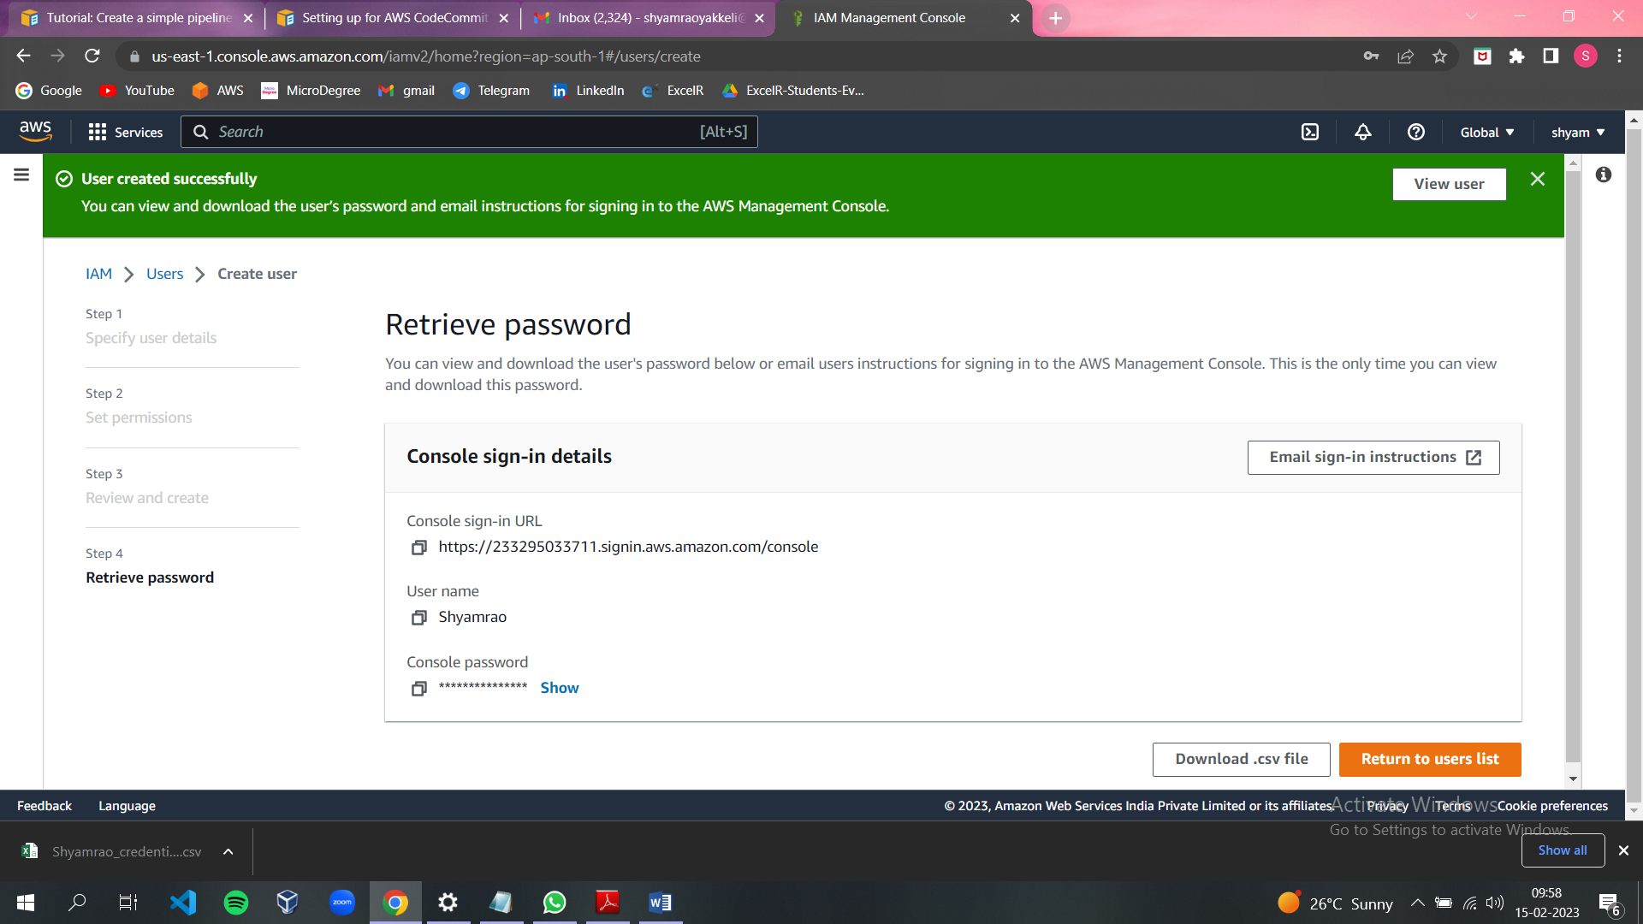

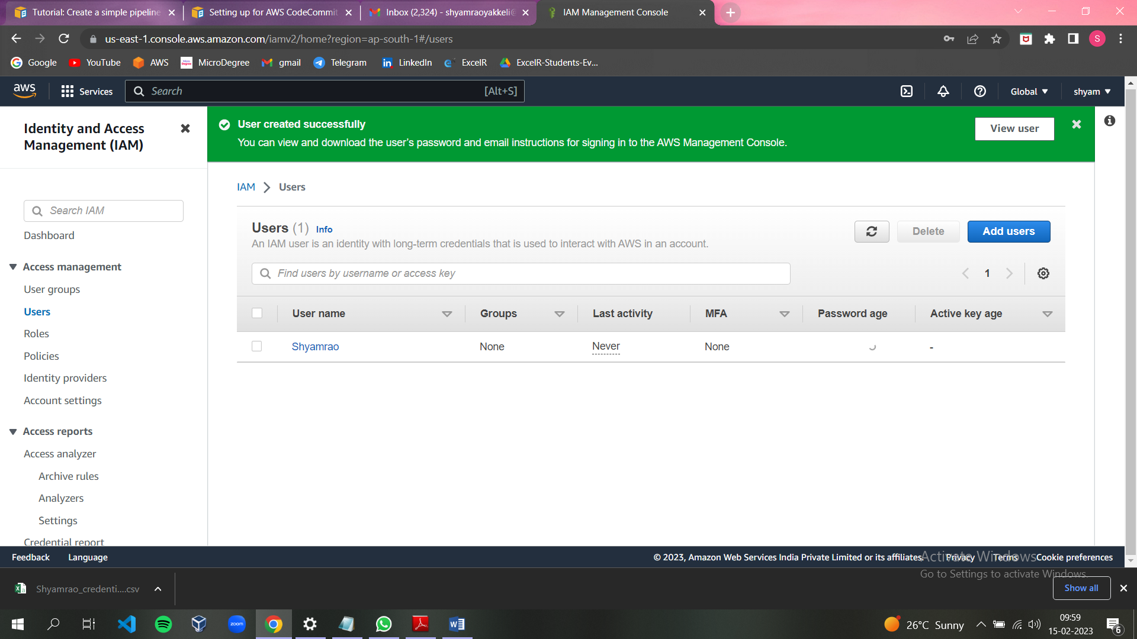

We can add permissions as we need from root account.

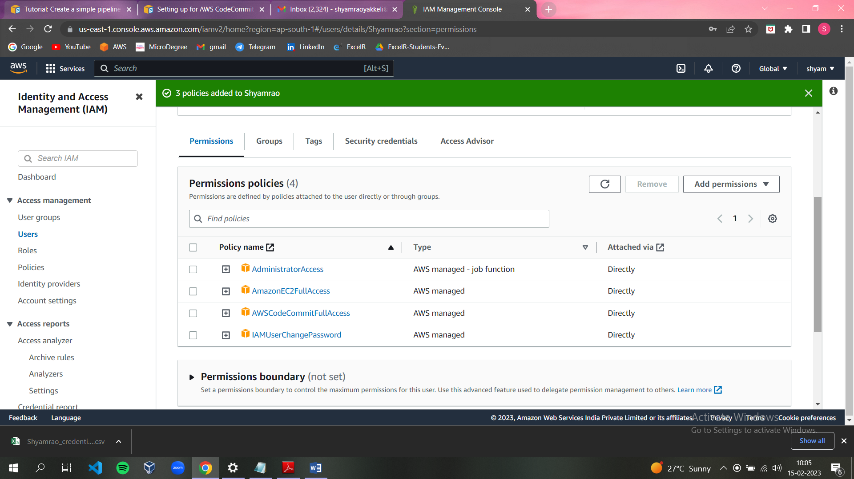

Then we have to login from IAM user account.

**CODE COMMIT :**

* To create a code pipeline we need to add the code commit from aws service.

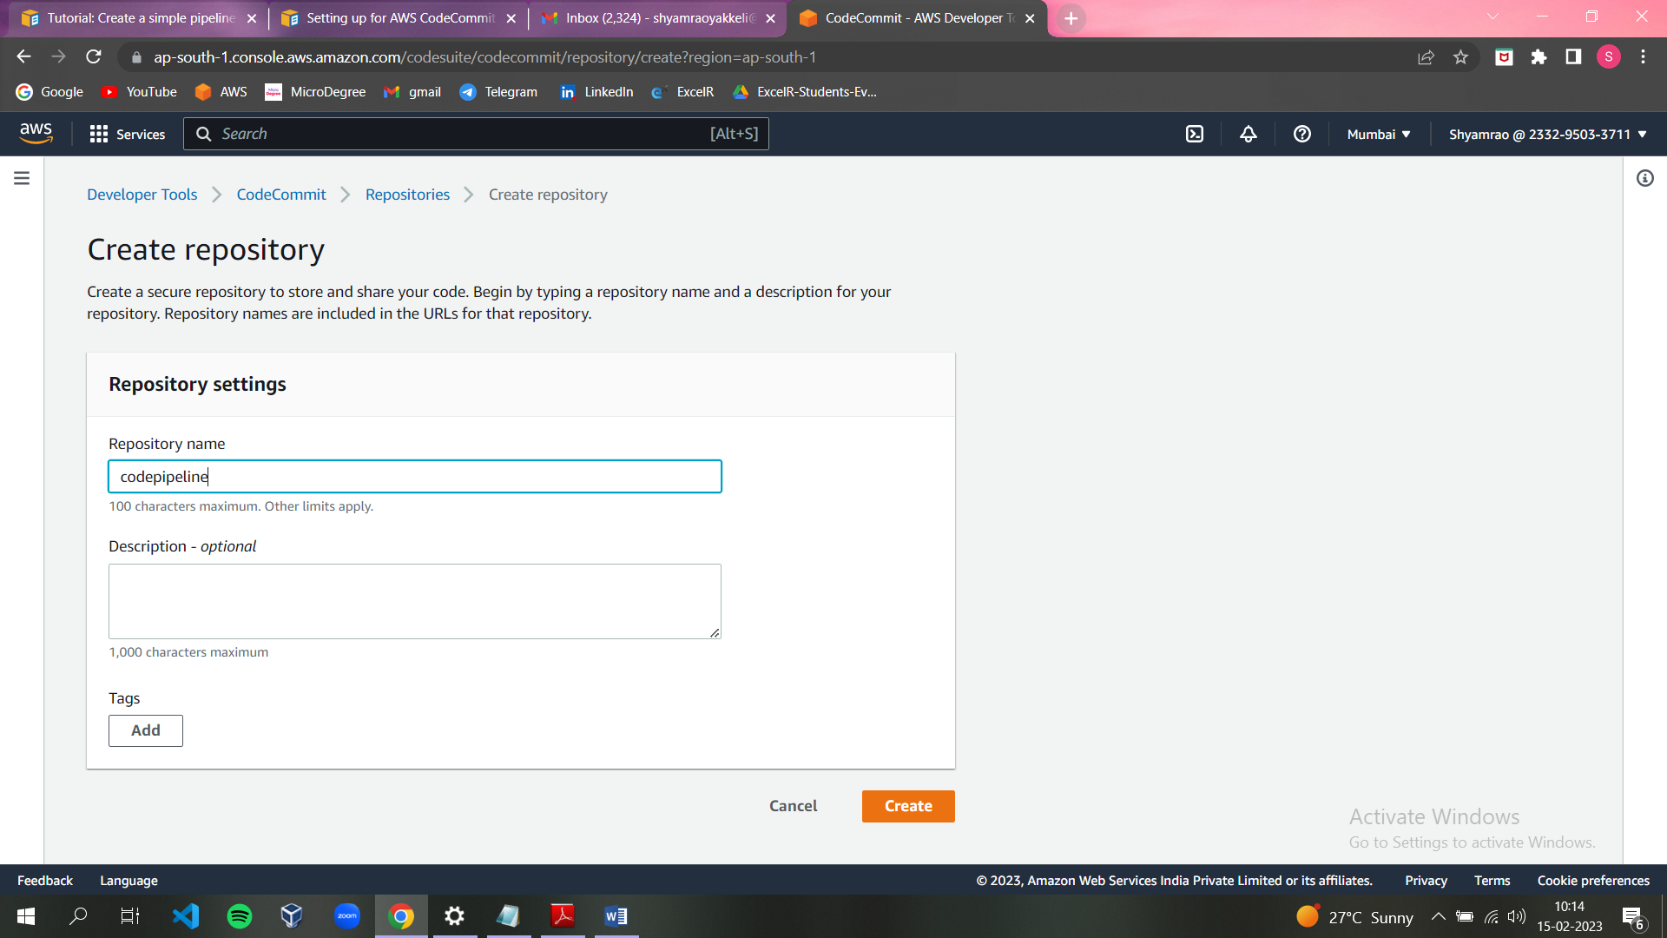

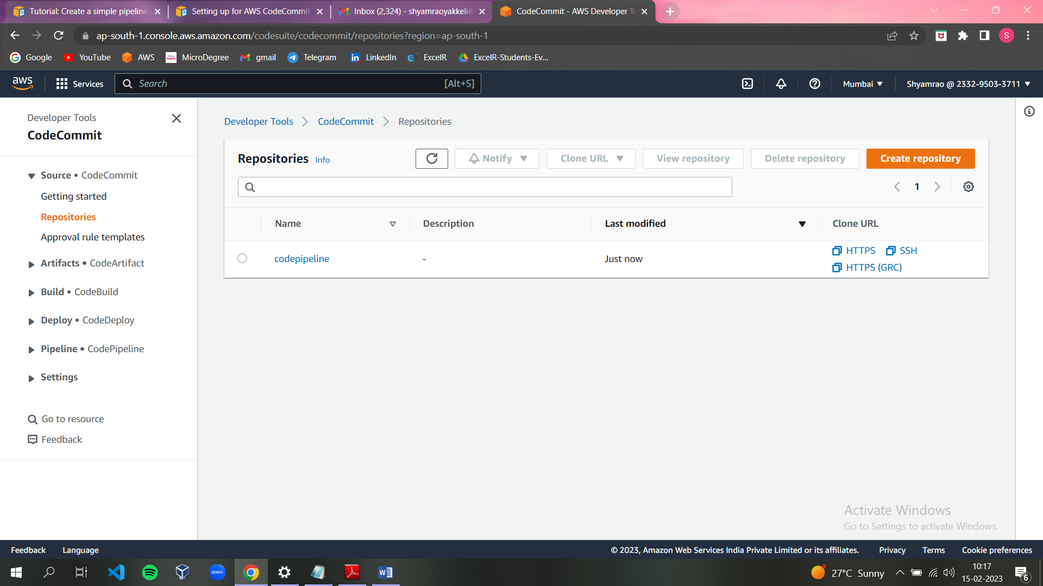

* Select the code pipeline follow the instructions.

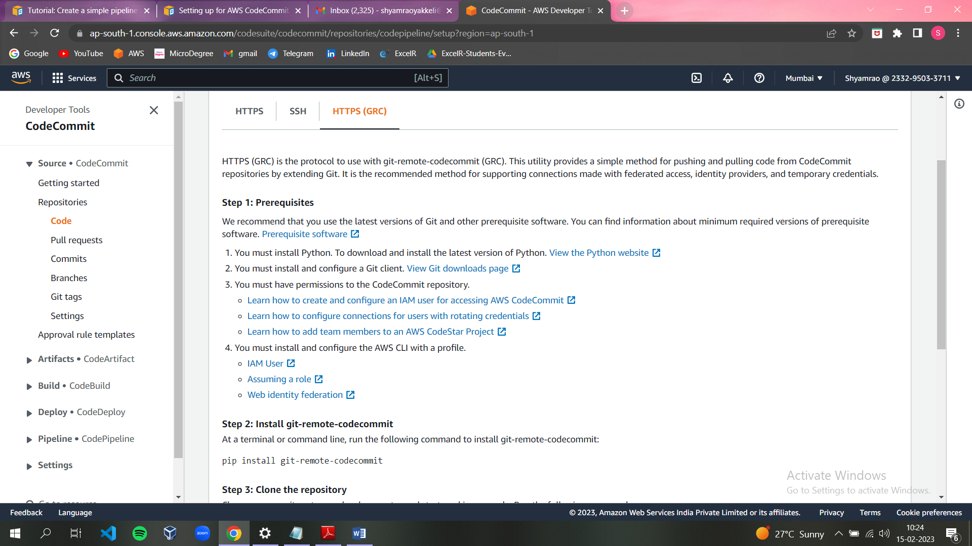

* We need to download and install latest versions of python and git.

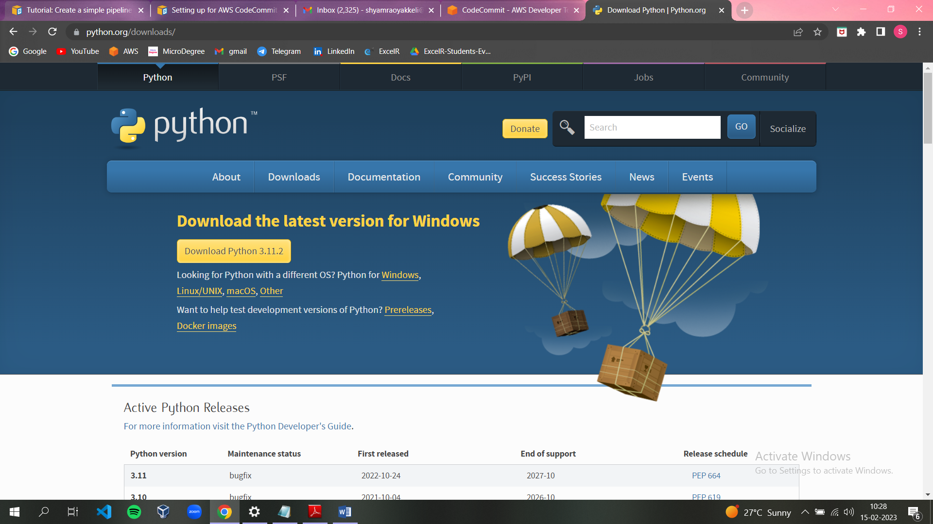

* 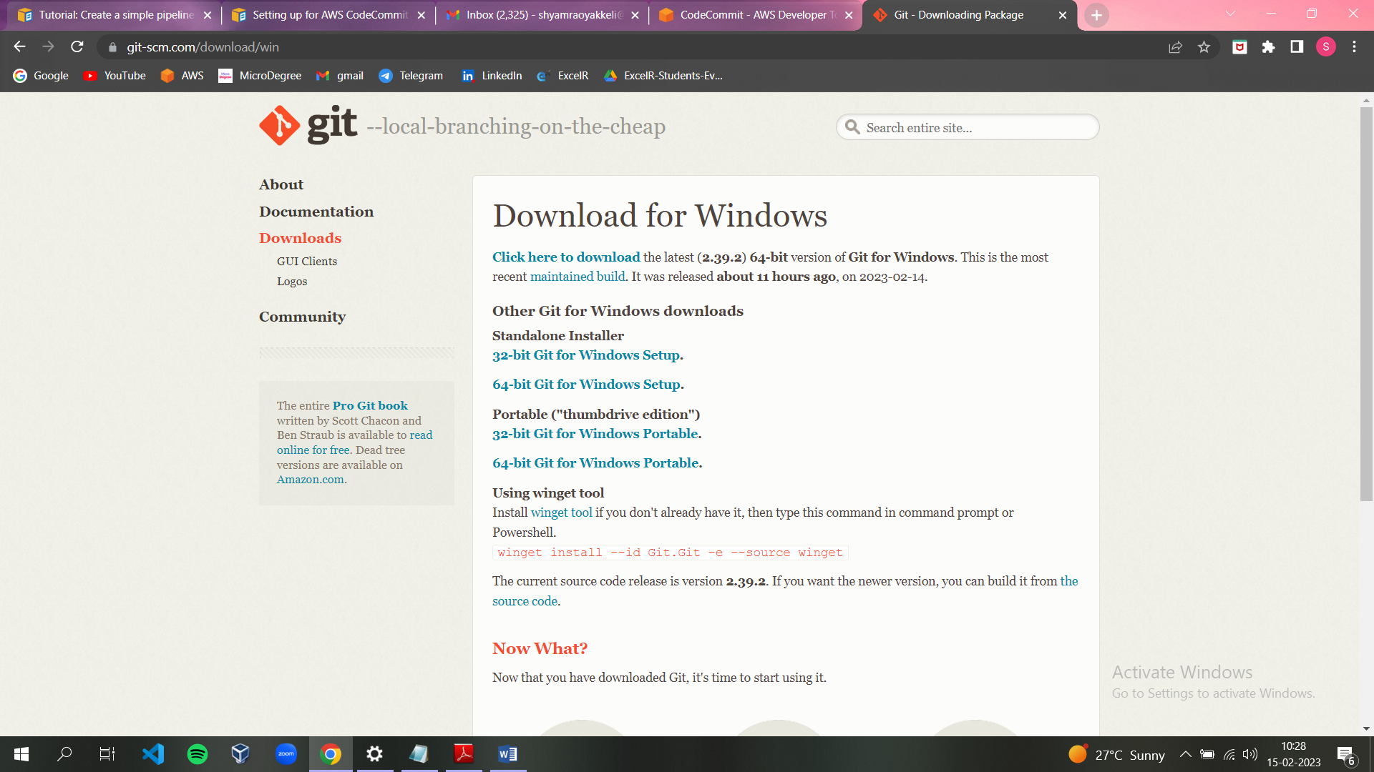

**ROLE** :

* We need to create a role for code commit.

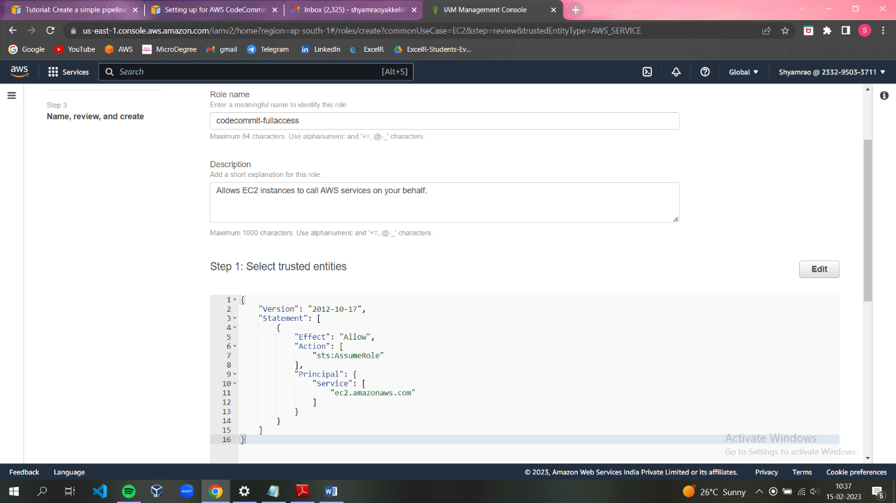

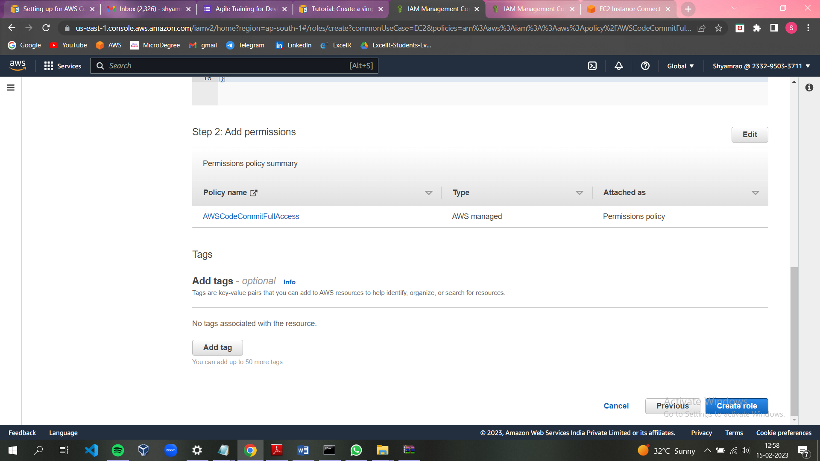

* We need to install git remote code commit

Command : pip install git-remote-codecommit

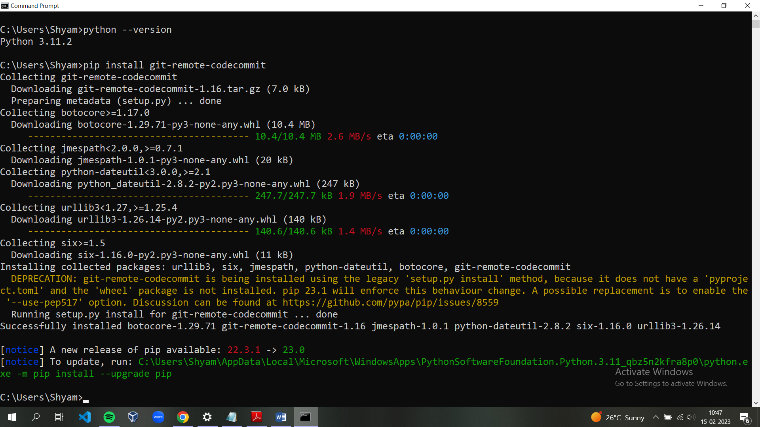

* Clone the repository

Command: <https://git-codecommit.ap-south-1.amazonaws.com>

/v1/repos/codepipeline

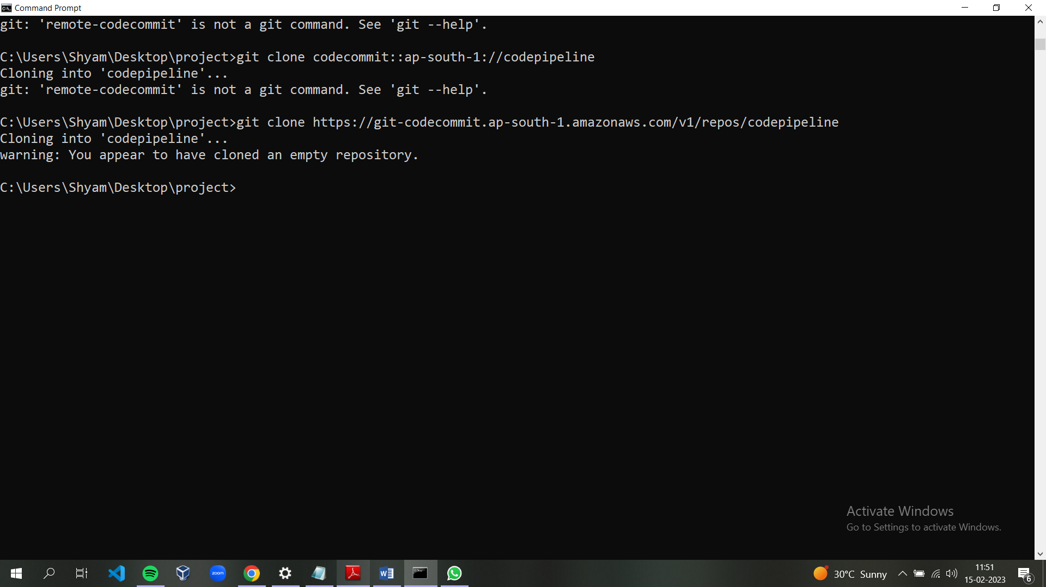

**a. Unzip the files from**

**https://docs.aws.amazon.com/codepipeline/latest/userguide/samples/SampleApp_Linux.zip into the local directory (for example, /tmp/MyDemoRepo or c:\temp\MyDemoRepo).**

**Be sure to place the files directly into your local repository.**

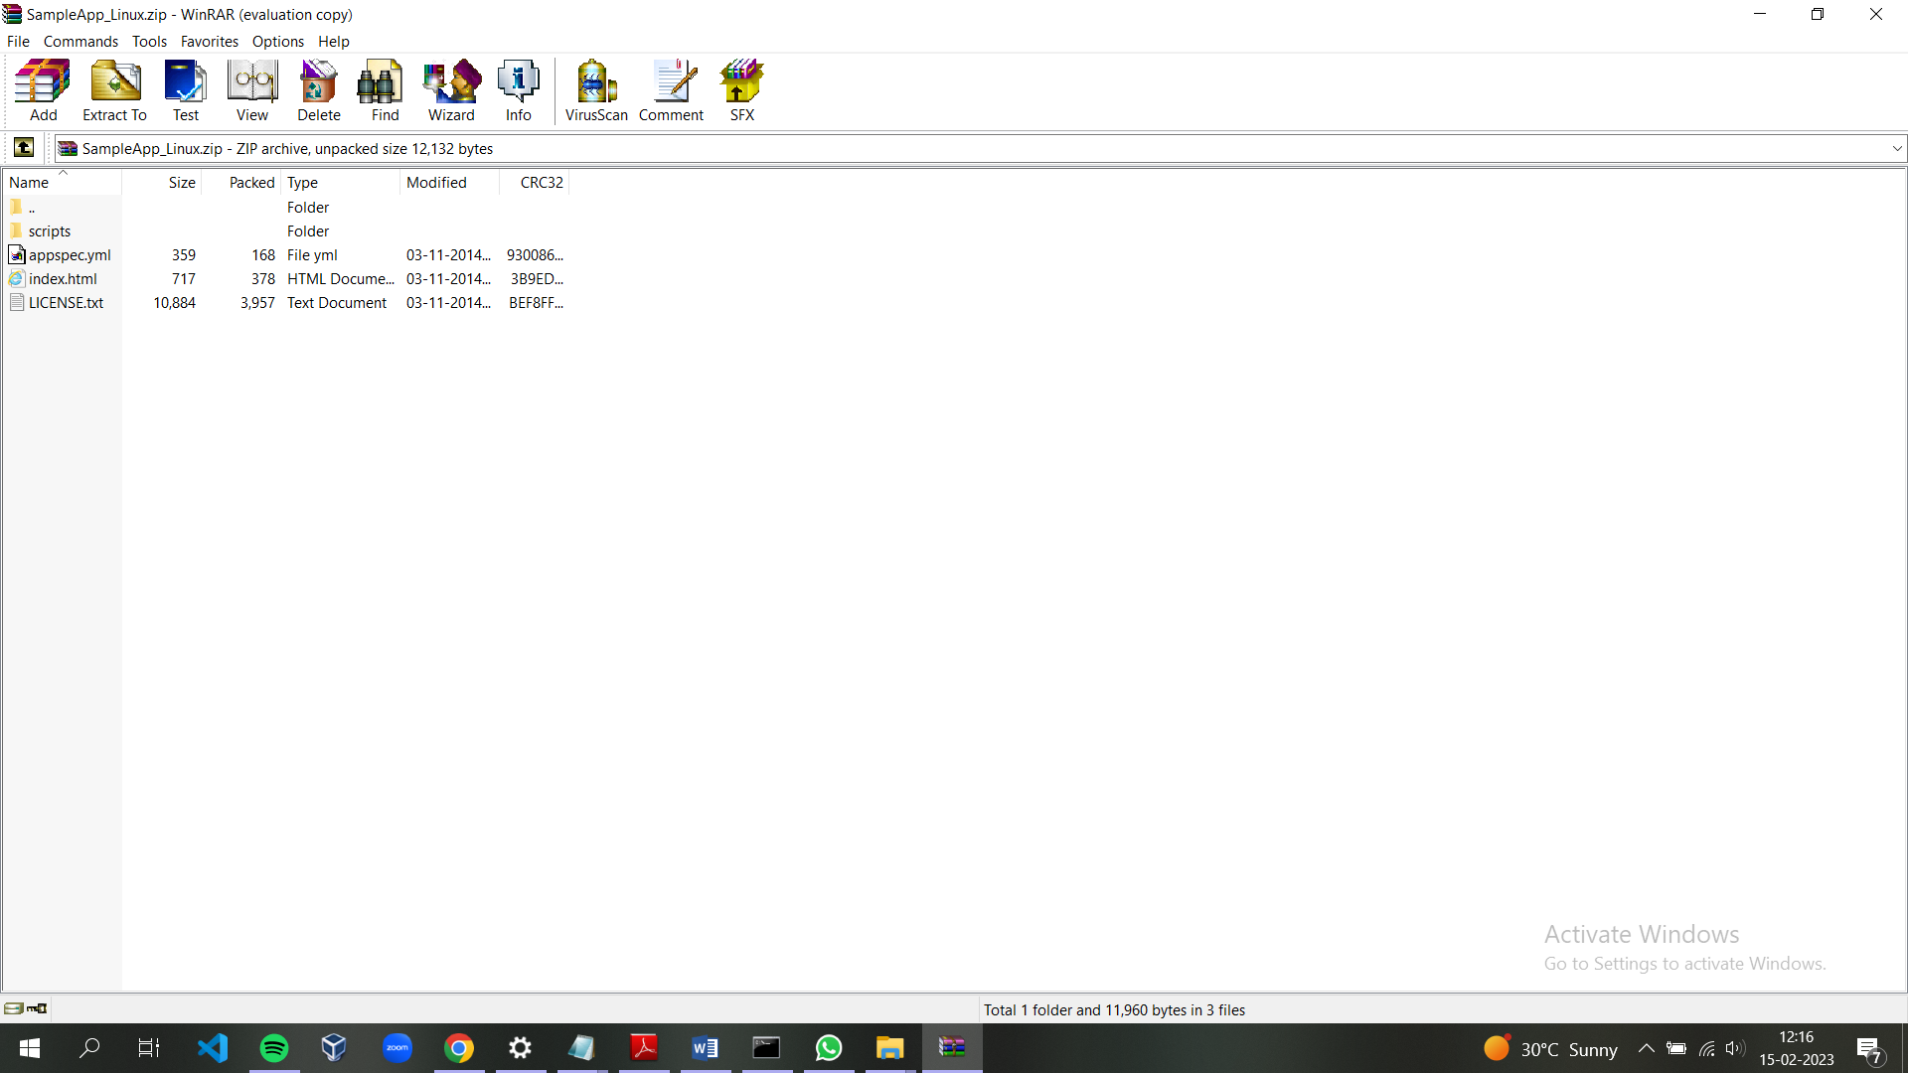

1. **Use git commands to upload the code in the local directory to public repository in Codecommit:**

Copy the unzip files and palce under a local repository and check the git status.

Command : git status

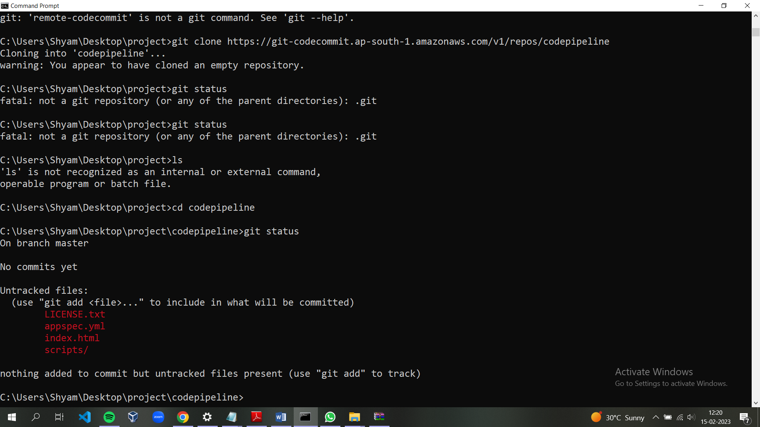

* Add the files to staging area:

Command : git add .

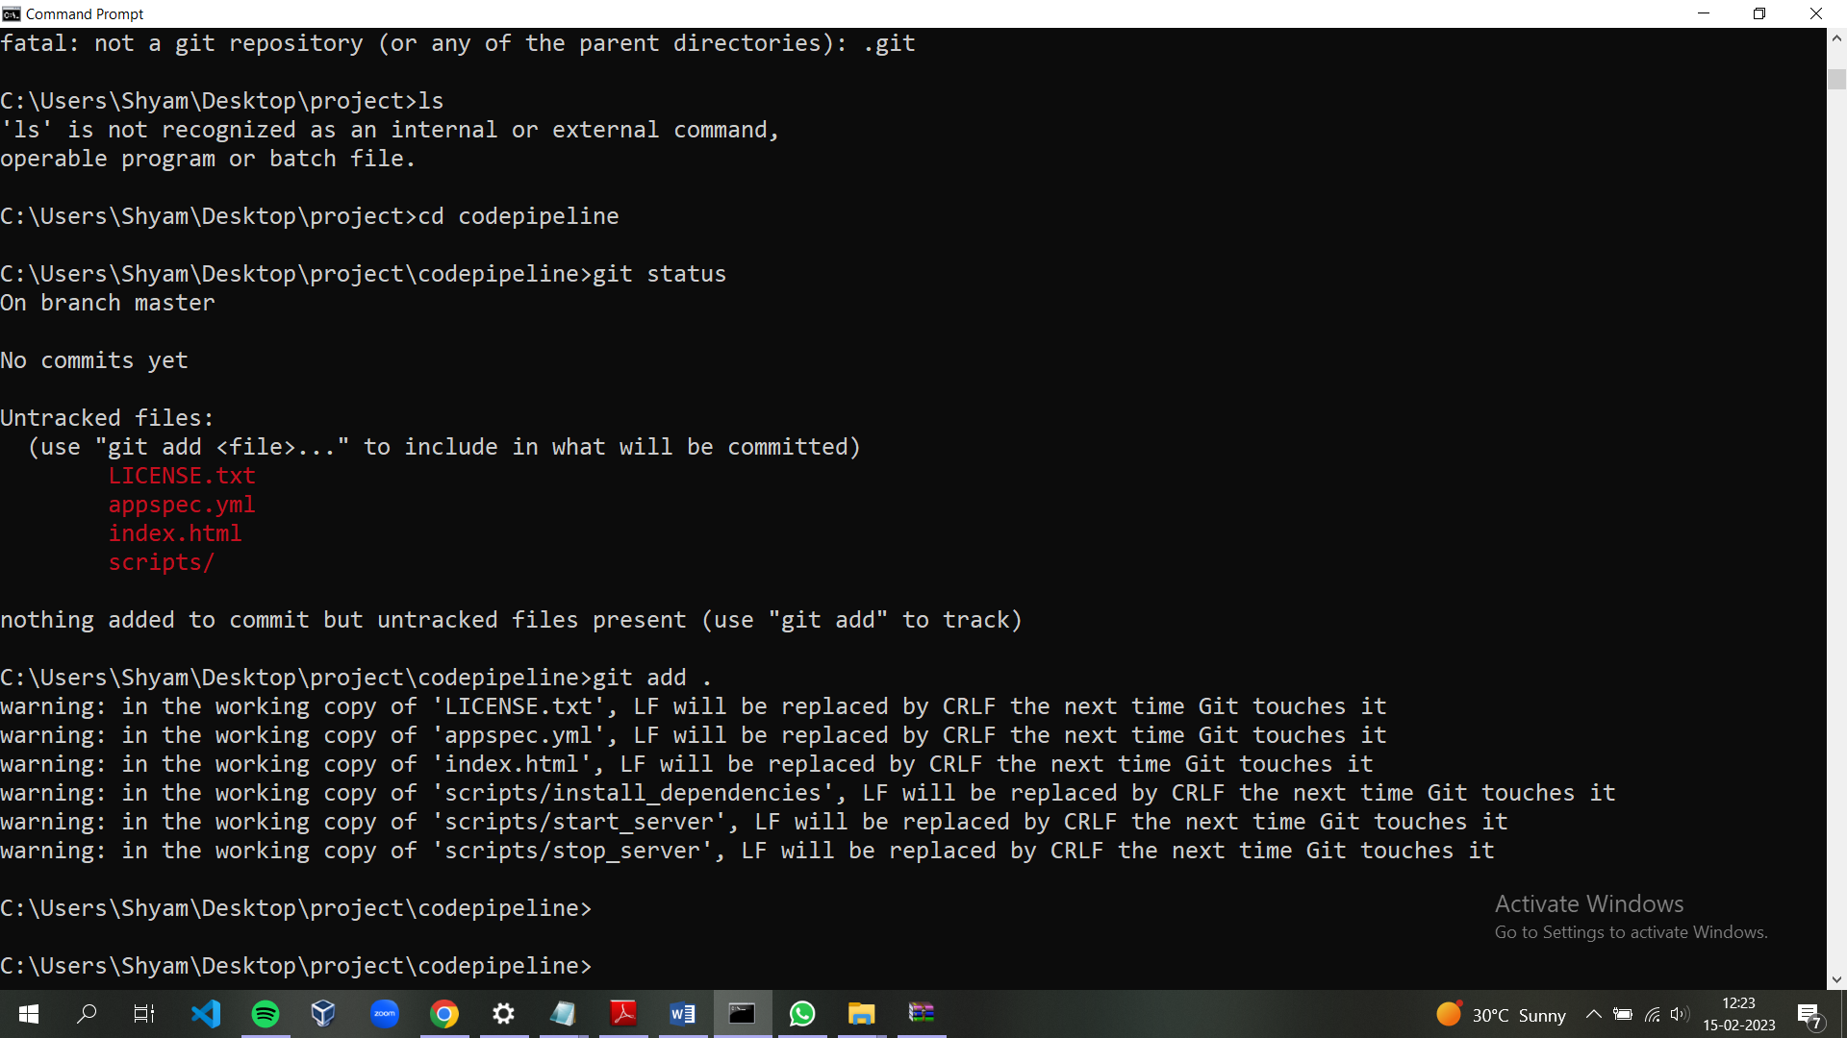

* Commiting the files:

Command : git commit –m “ committing in local repository”

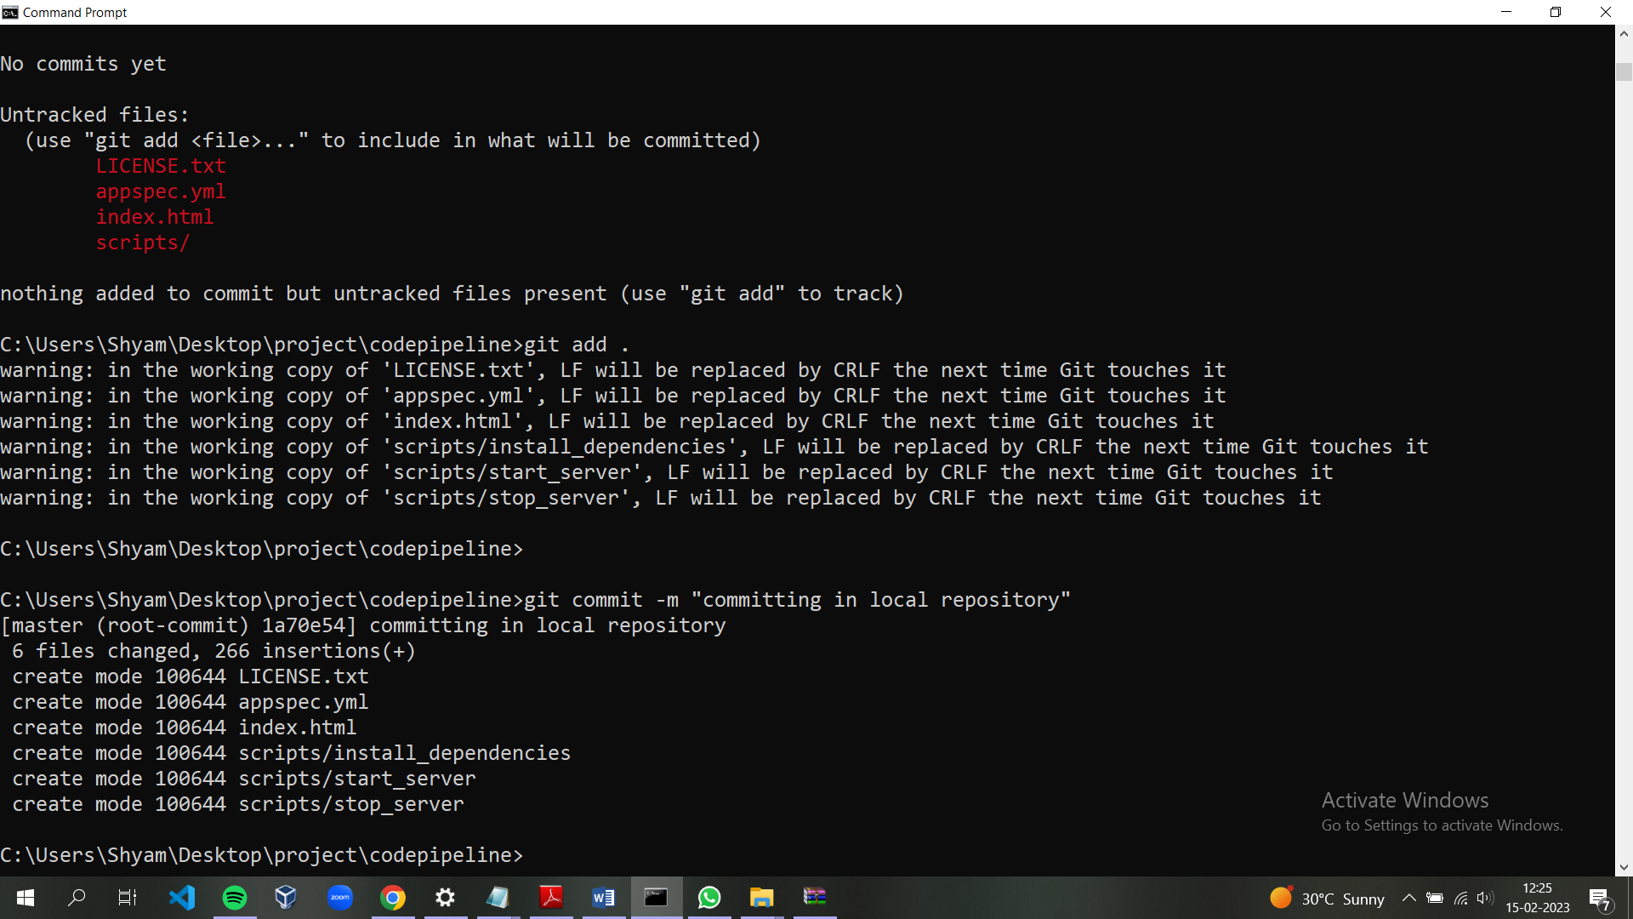

* Push the files to repository:

Command : git push

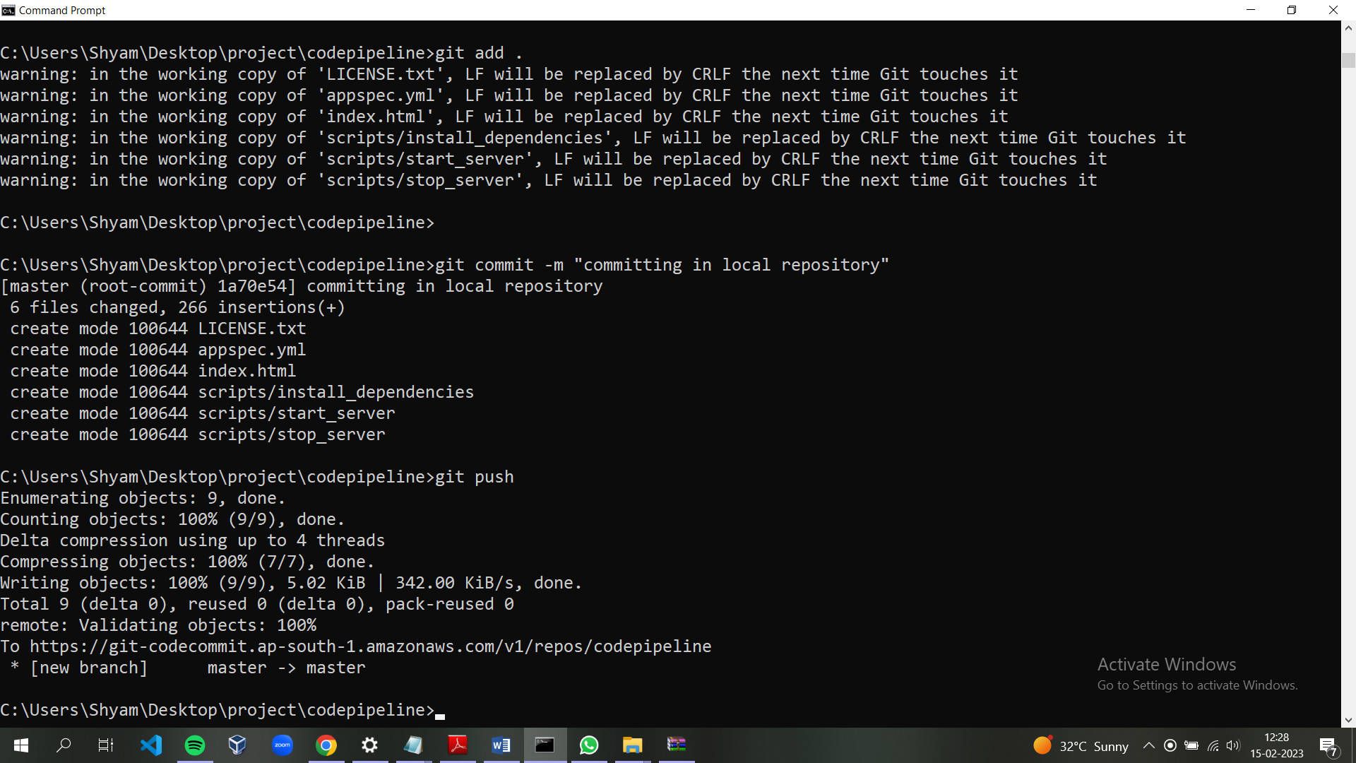

* Go to aws console in the repository we can all the files that we have pushed.

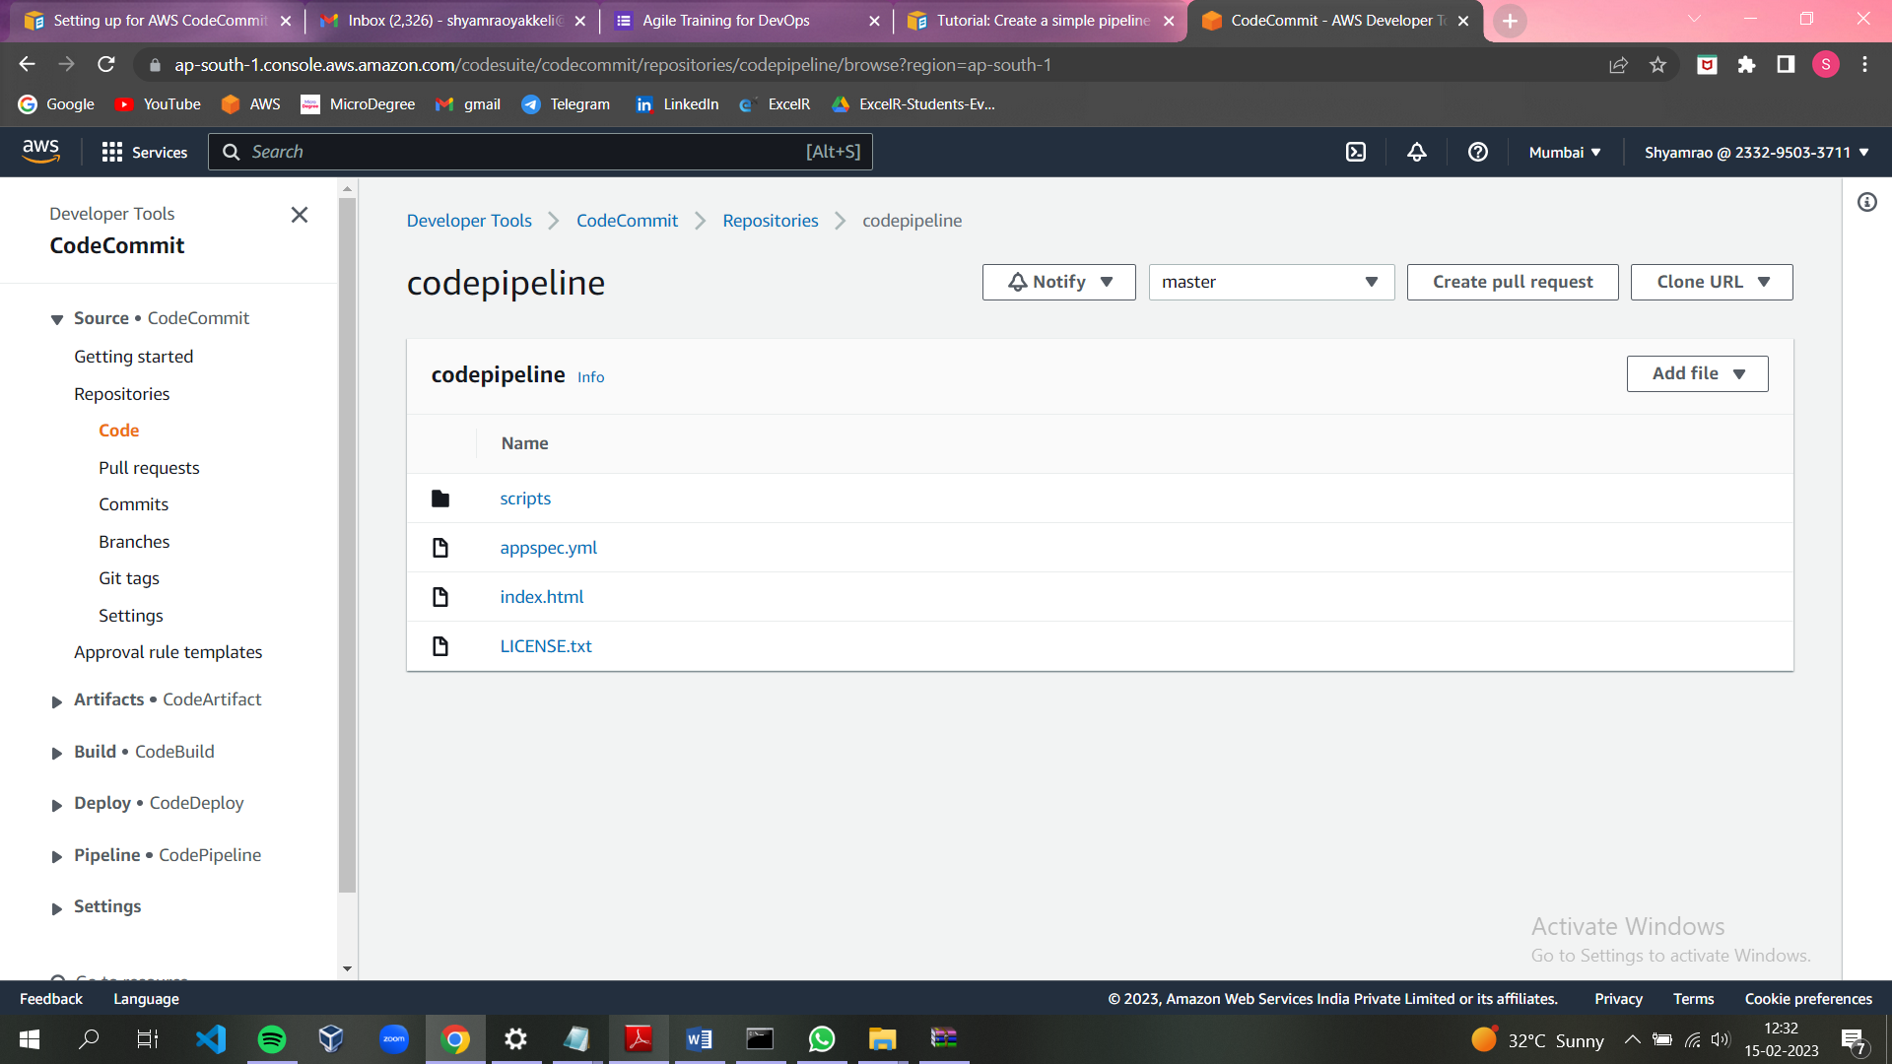

**CREATE AND CONFIGURE CODE-DEPLOY (AMAZON EC2)**

* Launch the amazon ec2 instance.

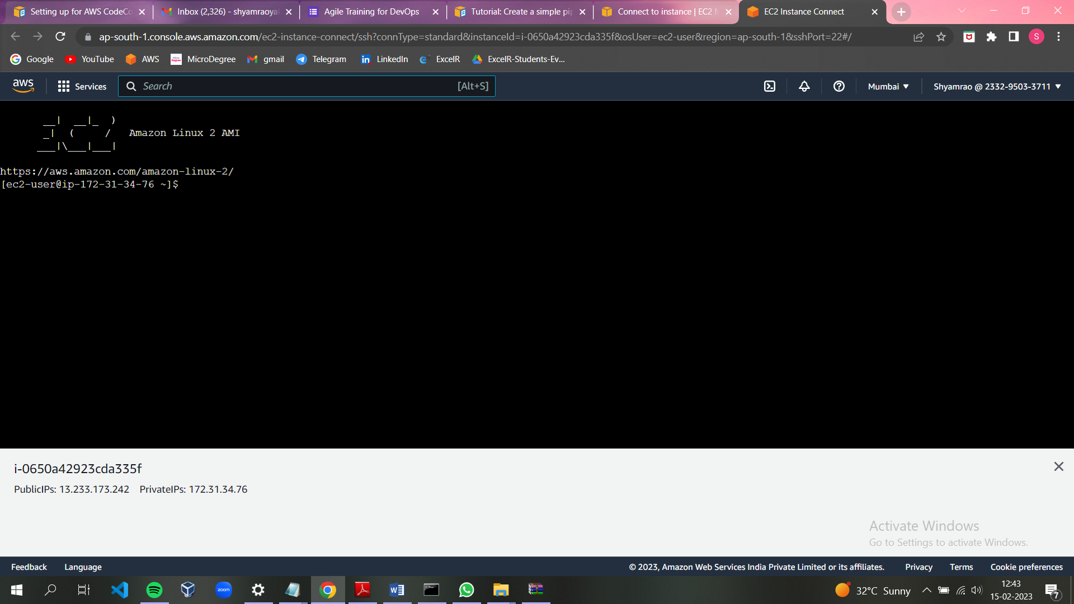

* Add the role for code-deploy from IAM user

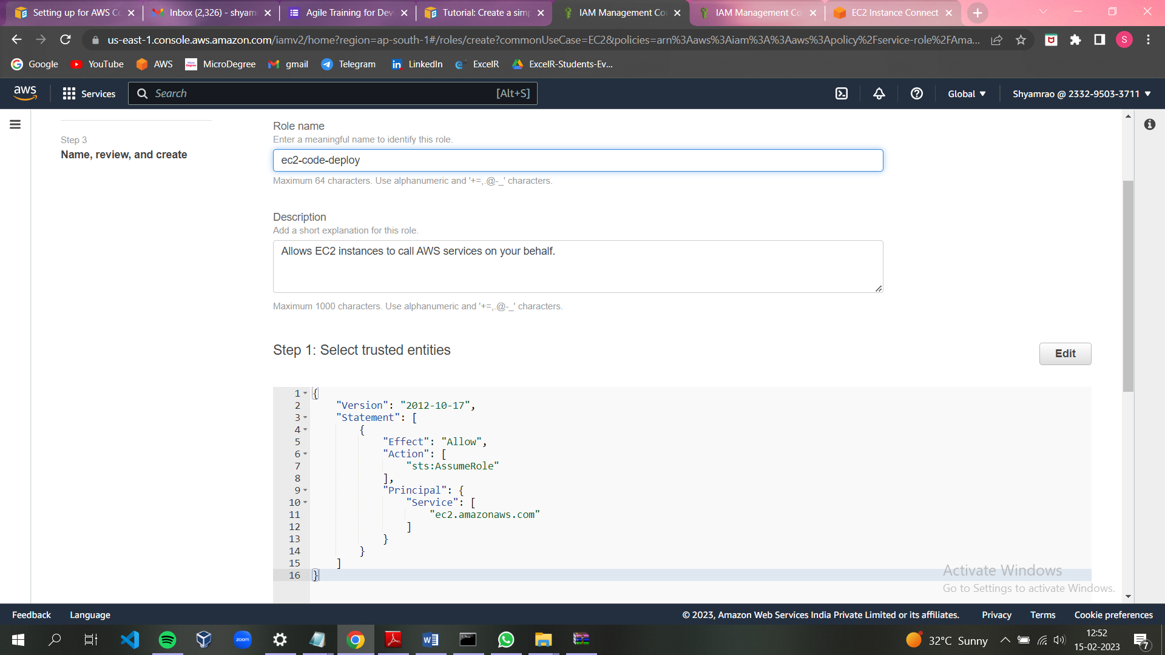

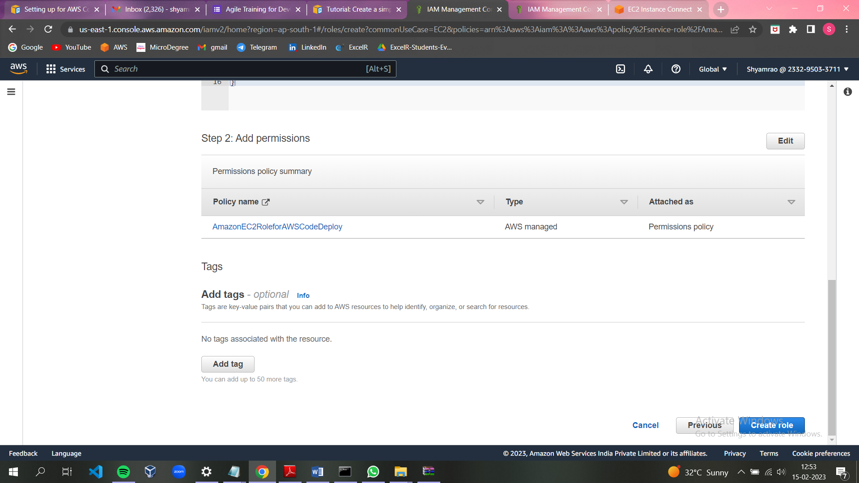

* Attaching the newly created IAM role to the ec2 instance.

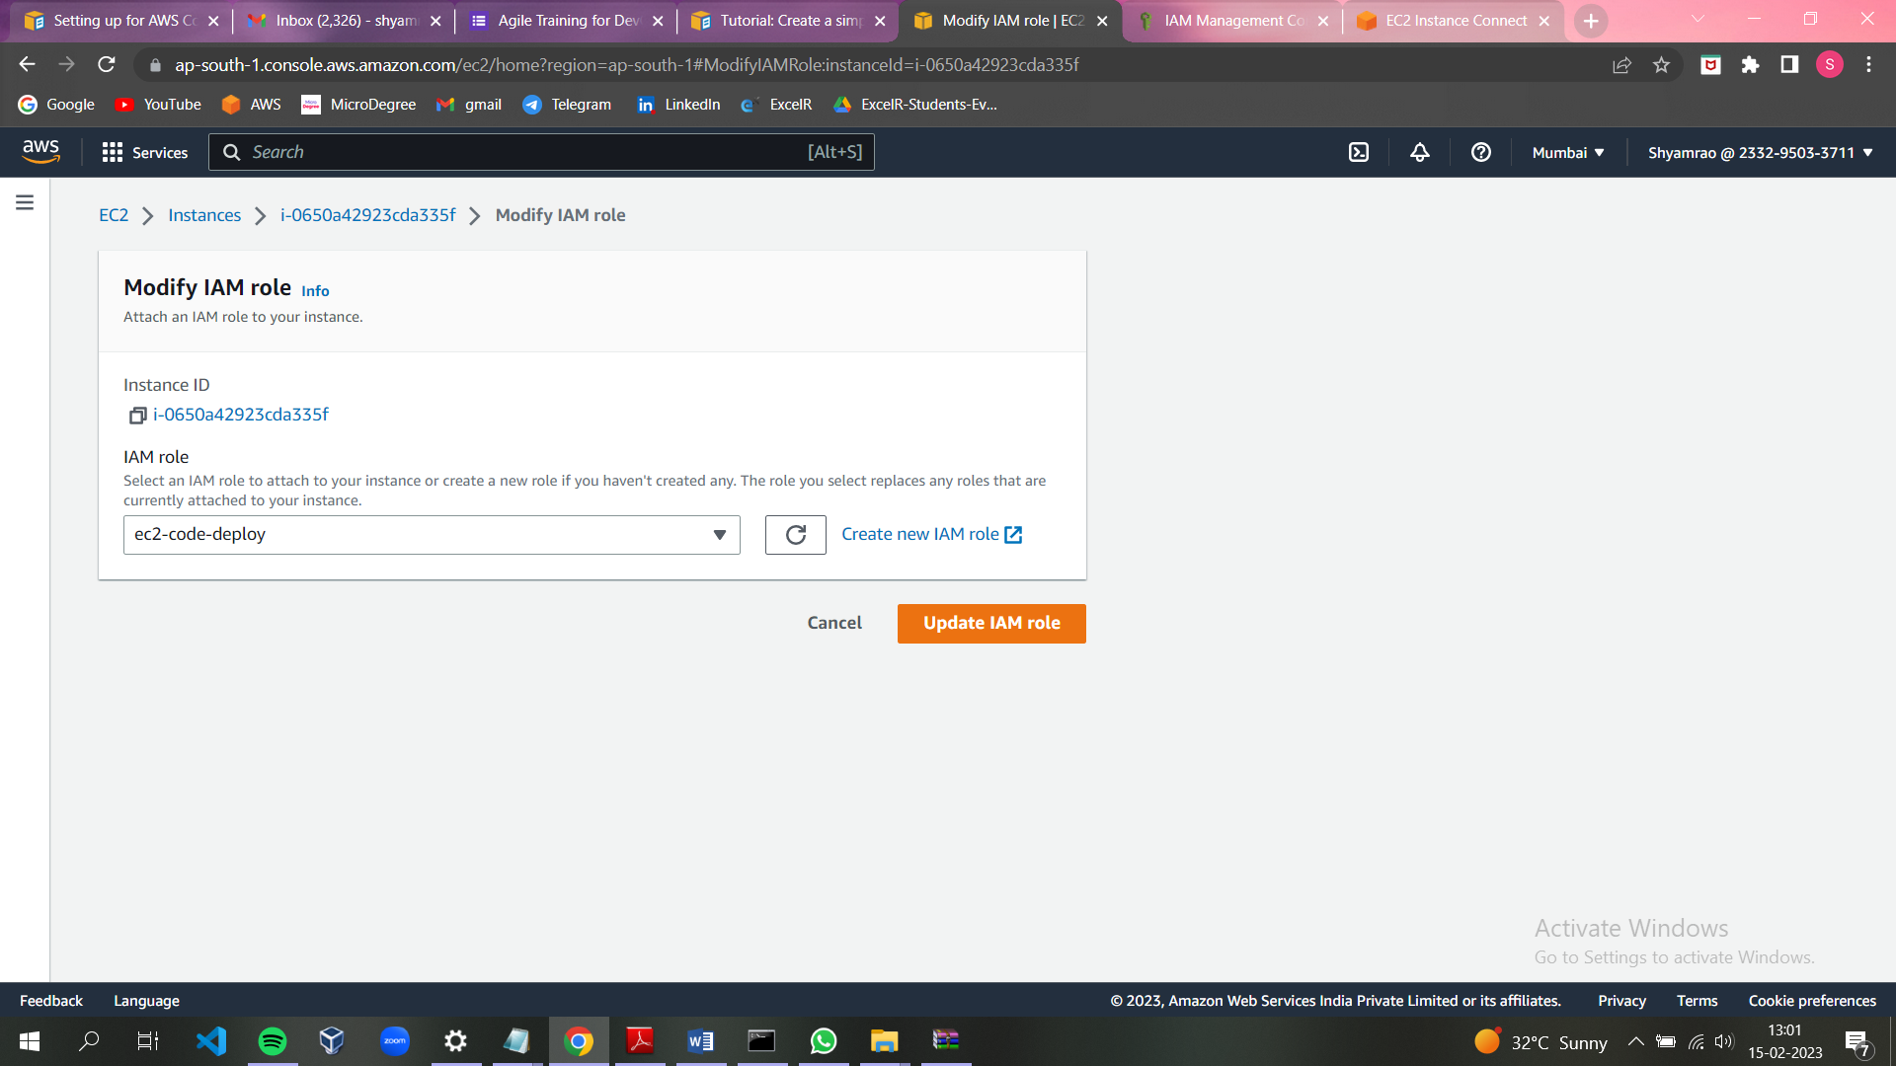

* Now we need to Install the Code Deploy agent for Amazon Linux or RHEL We can follow the steps from the below link.

https://docs.aws.amazon.com/codedeploy/latest/userguide/codedeploy-agent-operationsinstall-linux.html

* Update the system

Command: sudo yum update -y

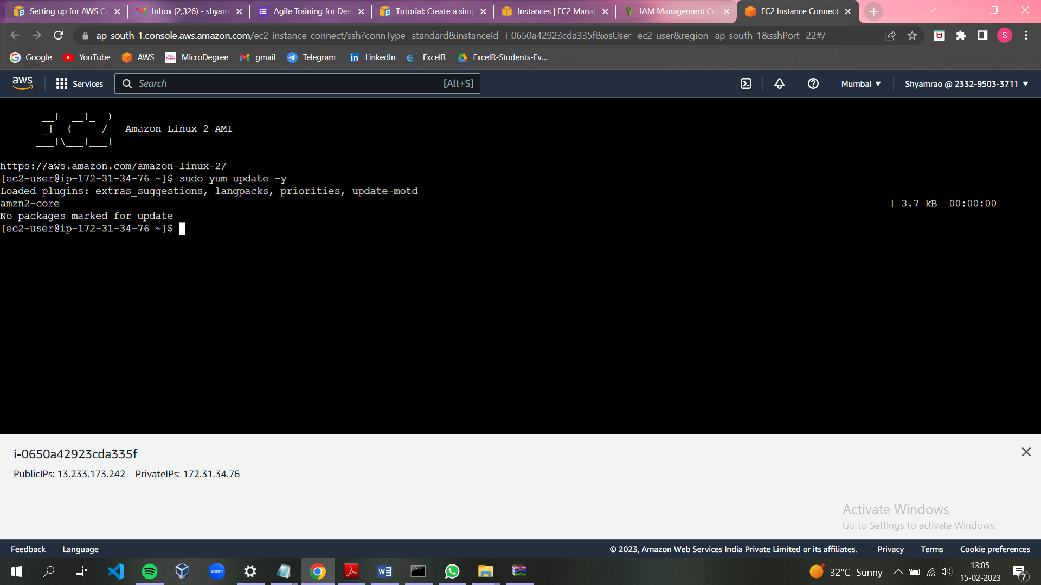

* Installing ruby

Command: sudo yum install ruby –y

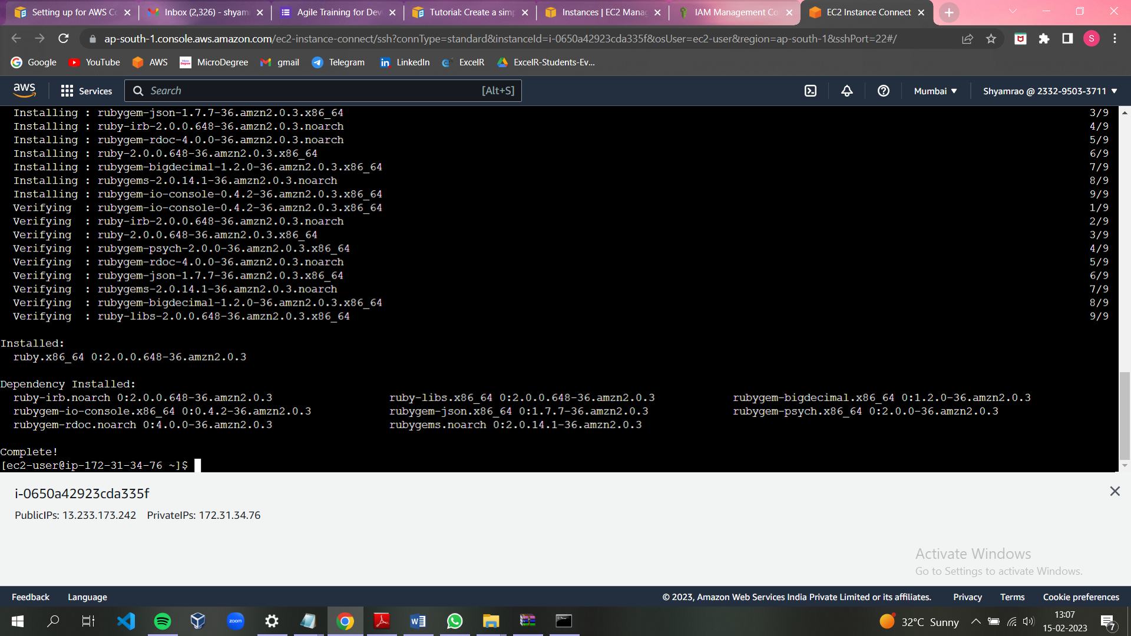

* Installing wget

Command: sudo yum install wget –y

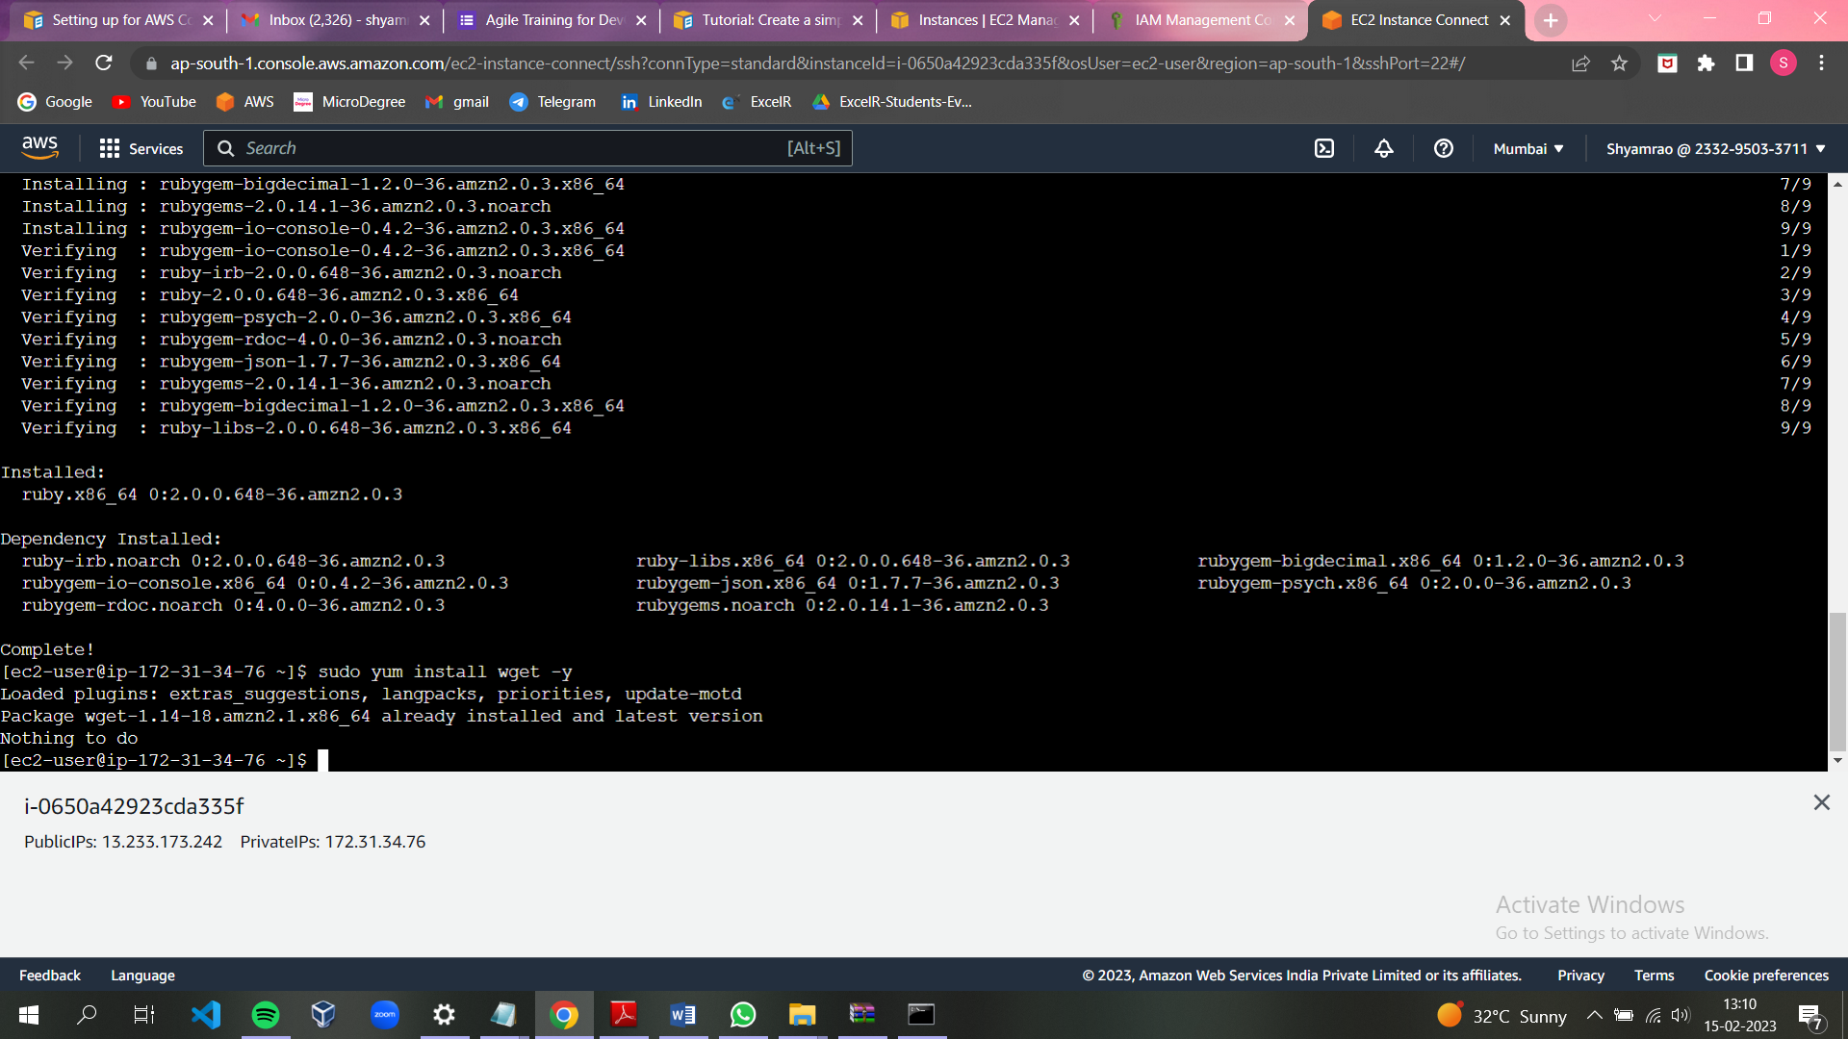

* Add the bucket name and region identifier in the wget path

Command:

wget <https://aws-codedeploy-ap-south-1.s3.ap-south-1.amazonaws.com/latest/install>

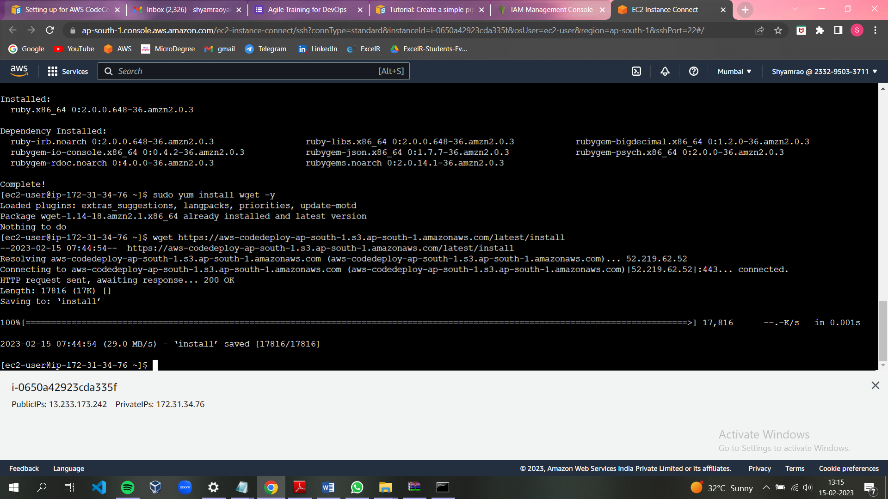

Commands: chmod +x ./install

Sudo ./install auto

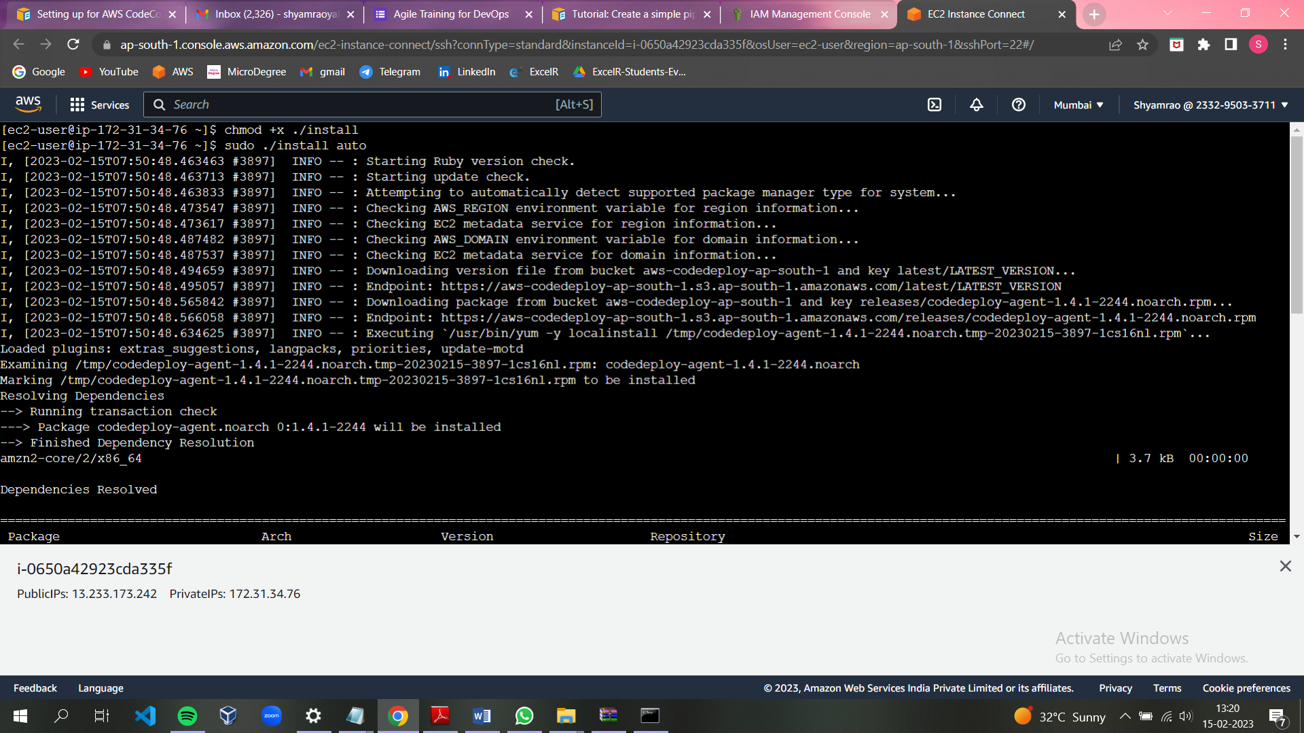

* To see the status of service

Sudo service codedeploy-agent status

* To start the servie

Sudo service codedeploy-agent start

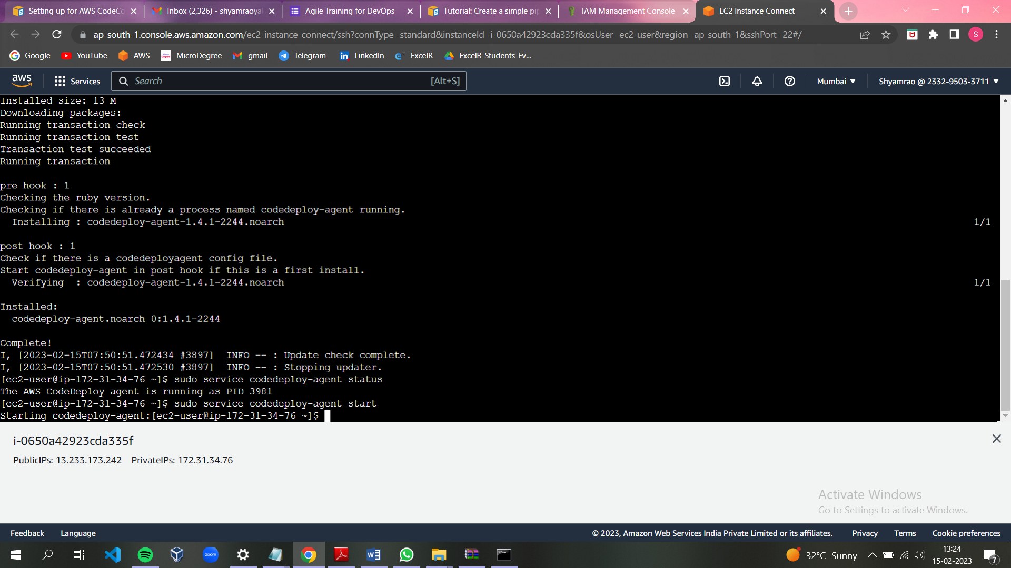

**Create a pipeline using AWS CodePipeline , AWS Code Commit and Code Deploy to deploy index.html to Amazon Linux ec2 instance .**

* Creating the application for the codepipeline from code deploy.

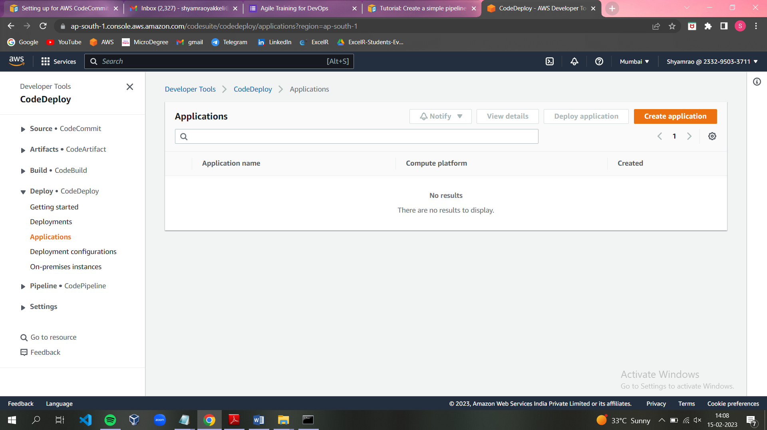

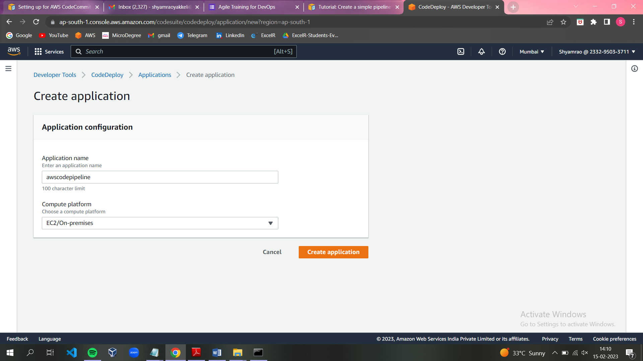

* We have to create a IAM role for codedeploy.

Add policy- AWSCodeDeloyRule

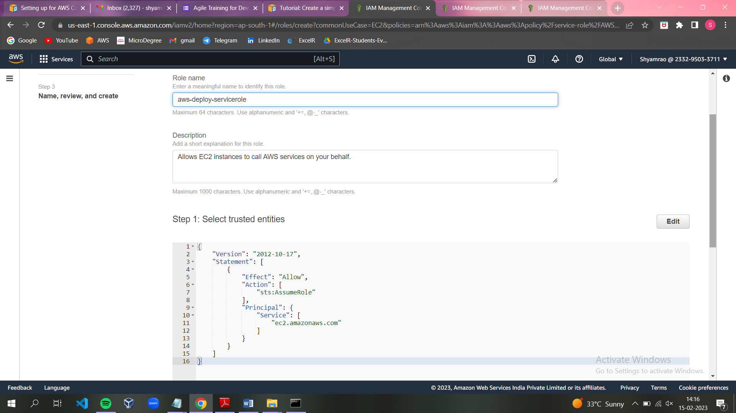

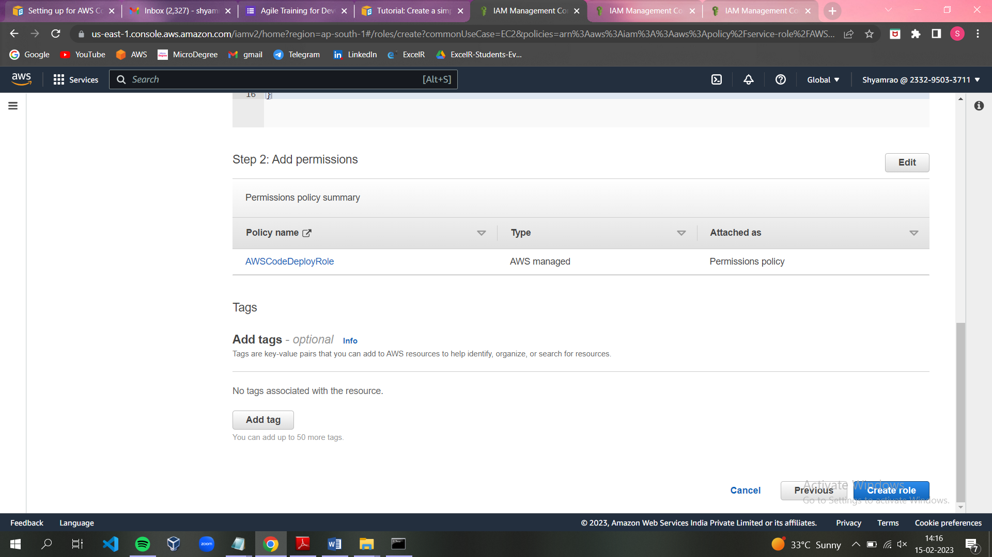

* Creating the deployment group

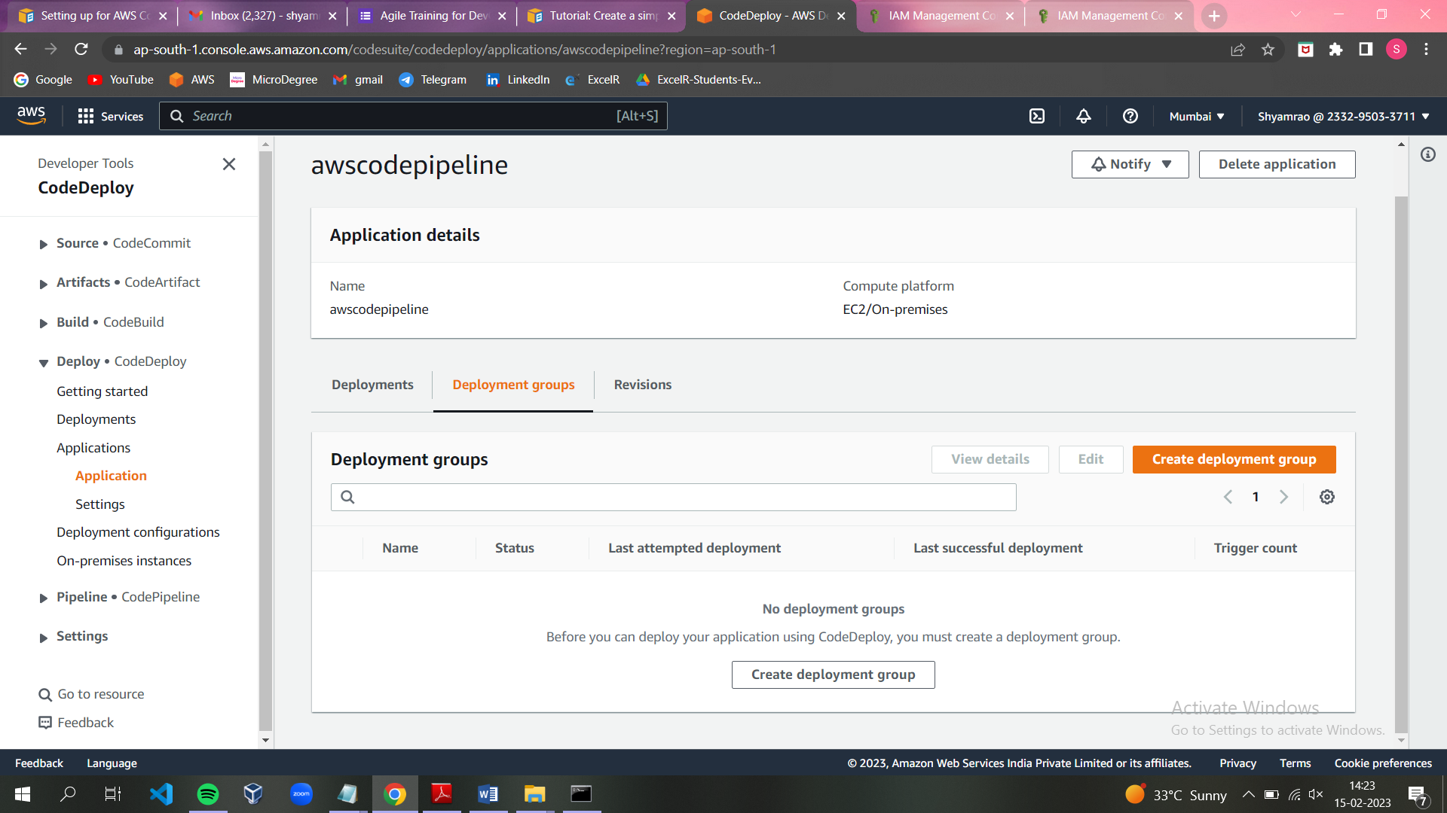

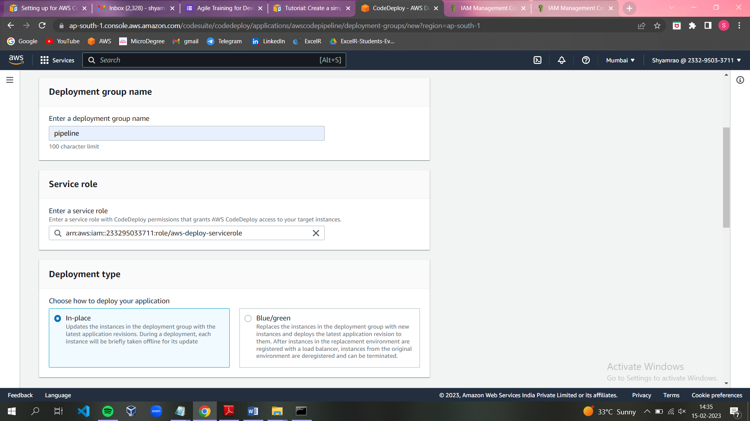

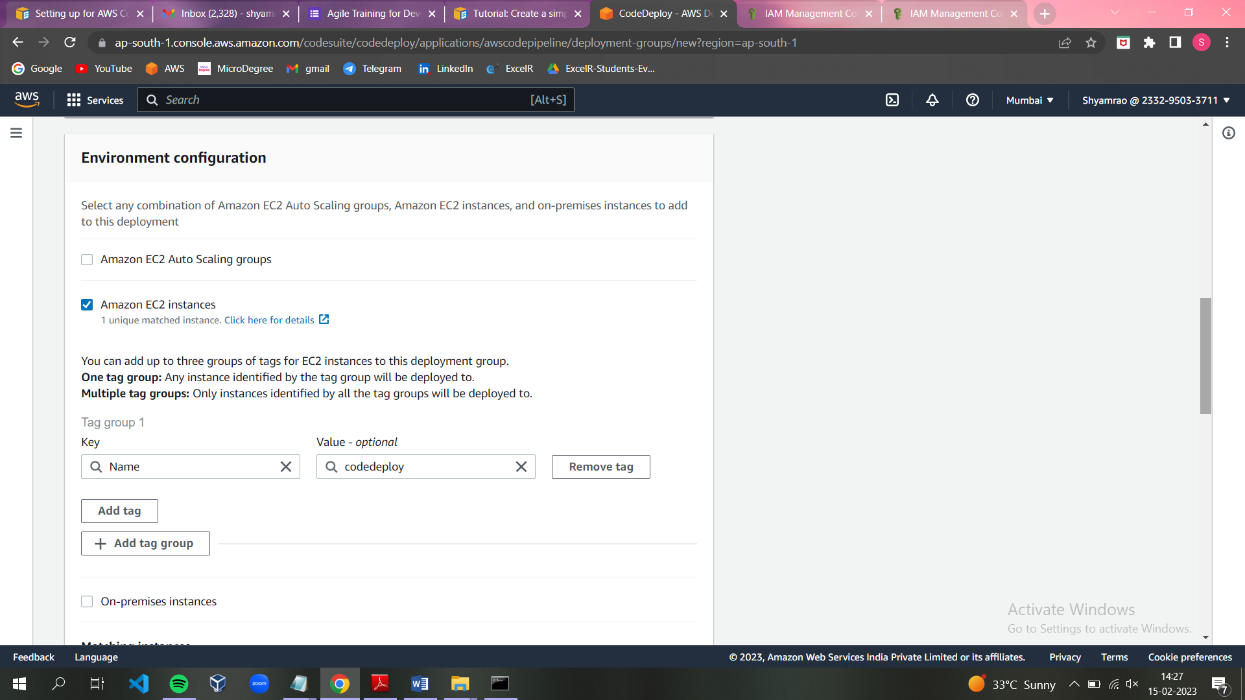

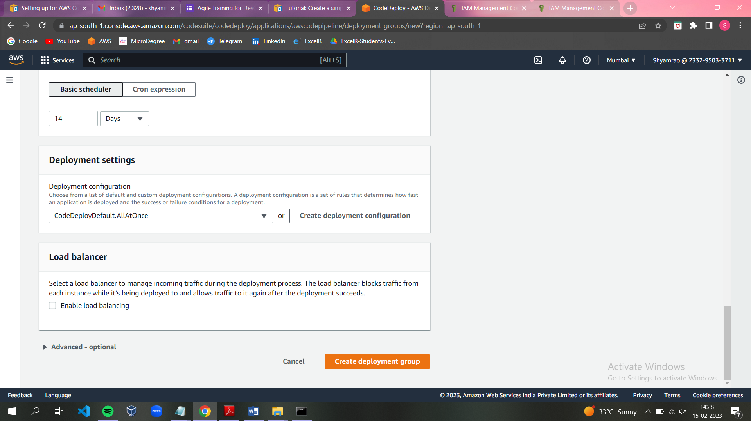

**Creating a pipeline:**

* Creating a pipeline from code-deploy.

**Step1:** choose pipeline settings

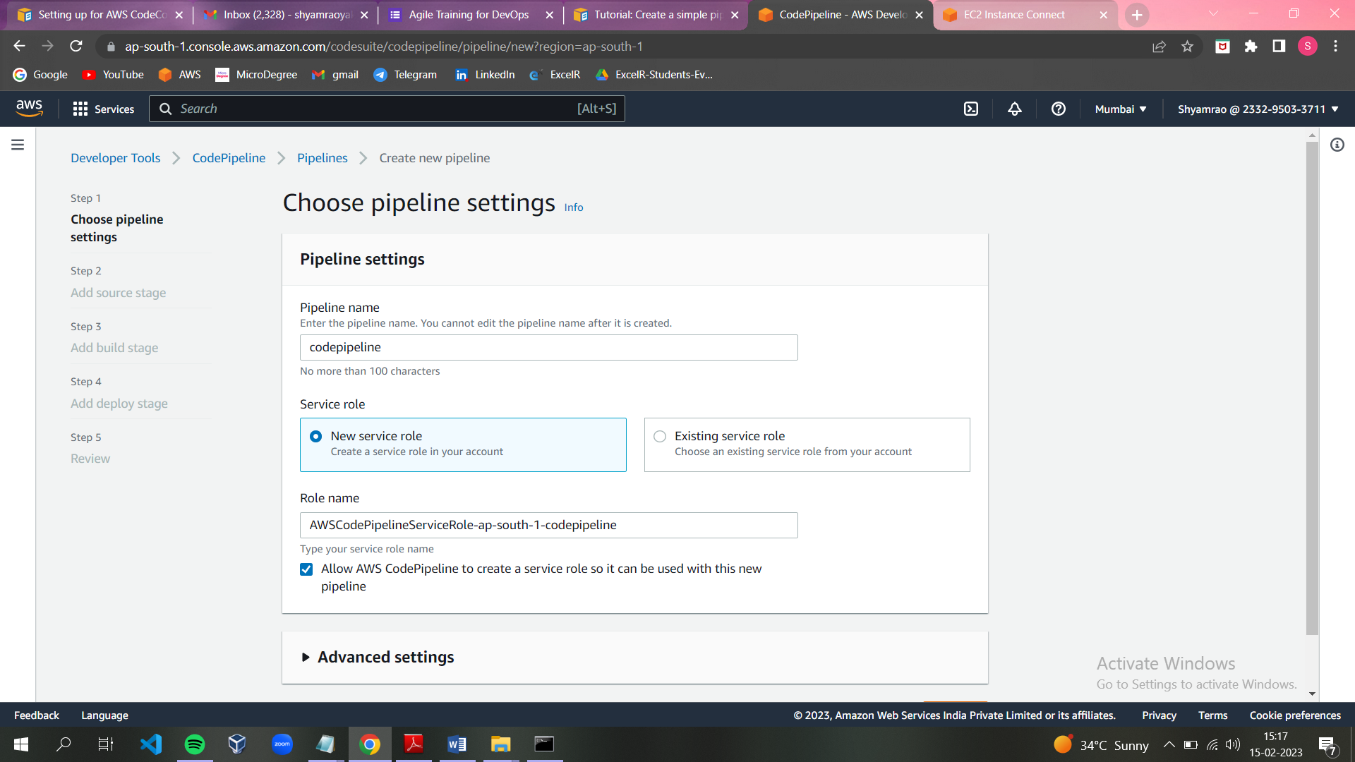

**Step2:** Add storage stage

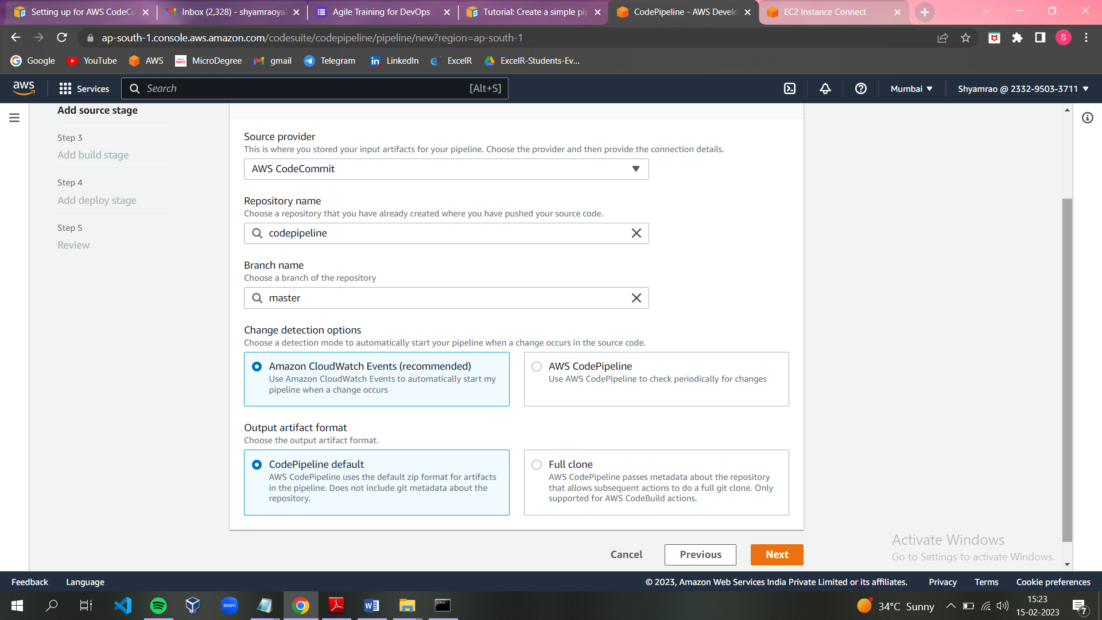

**Step3:** No build stage

**Step4:** Add deploy stage

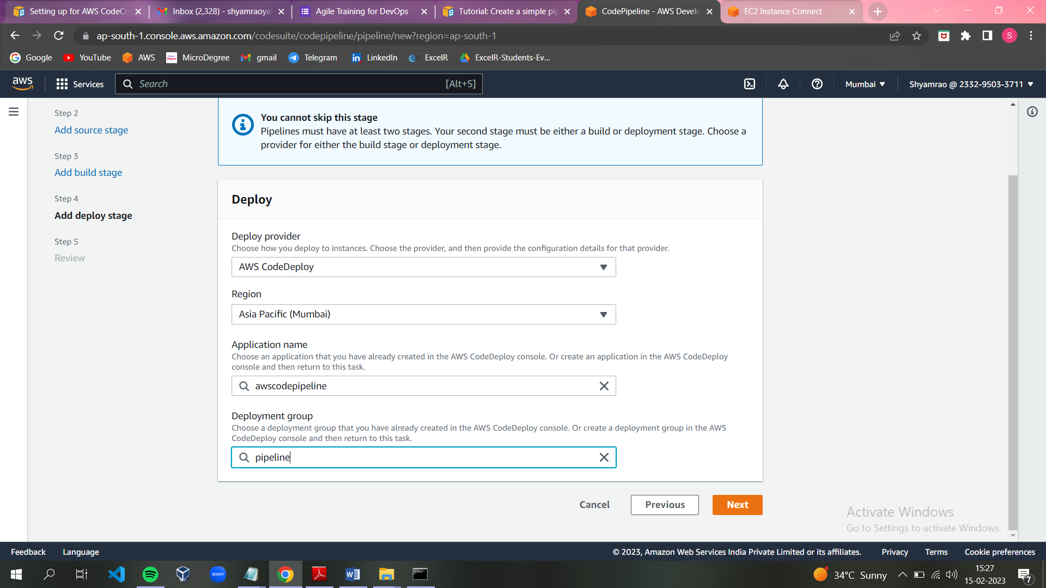

**Step5:** Review

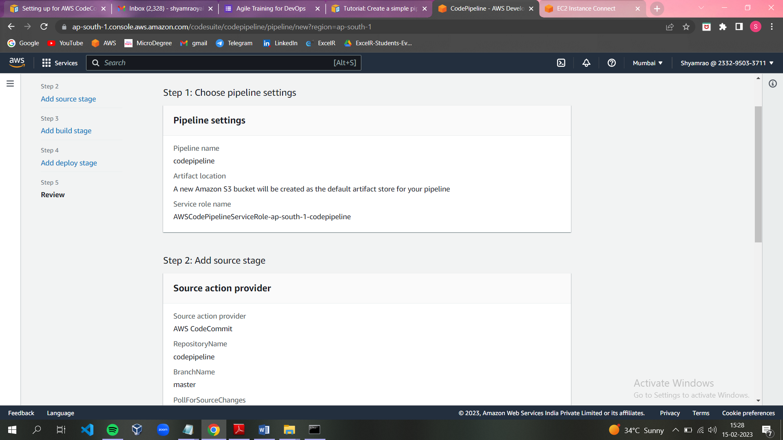

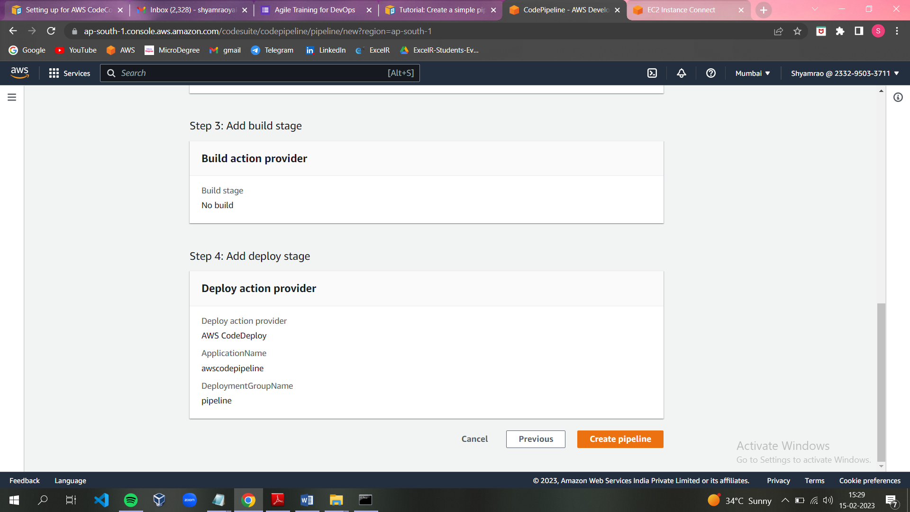

* Then application will be deploy:

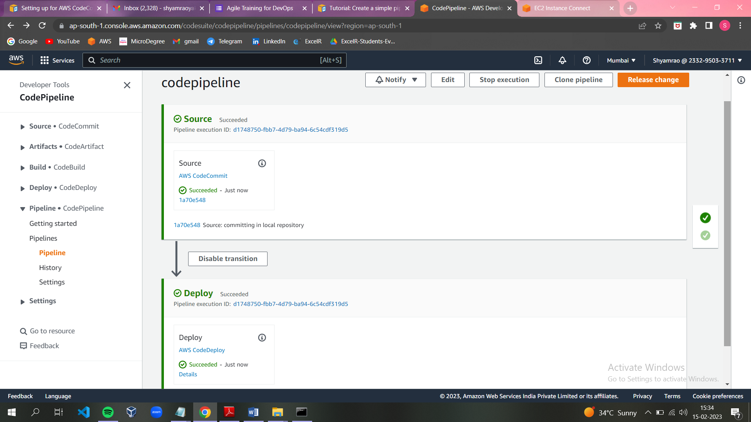

**Check the o/p , by accessing the public ip of the ec2 instance. Contents of the index.html must be displayed.**

* Edit the inbound rules of ec2 instance.

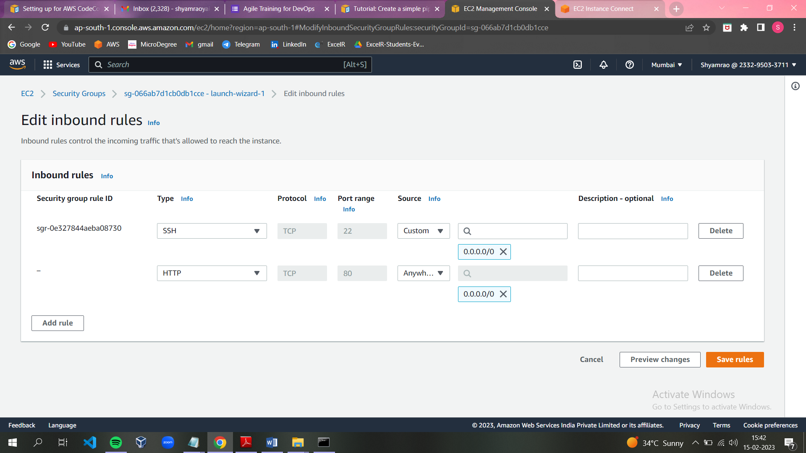

* Copy the public ip then paste it on browser and see the outputs.

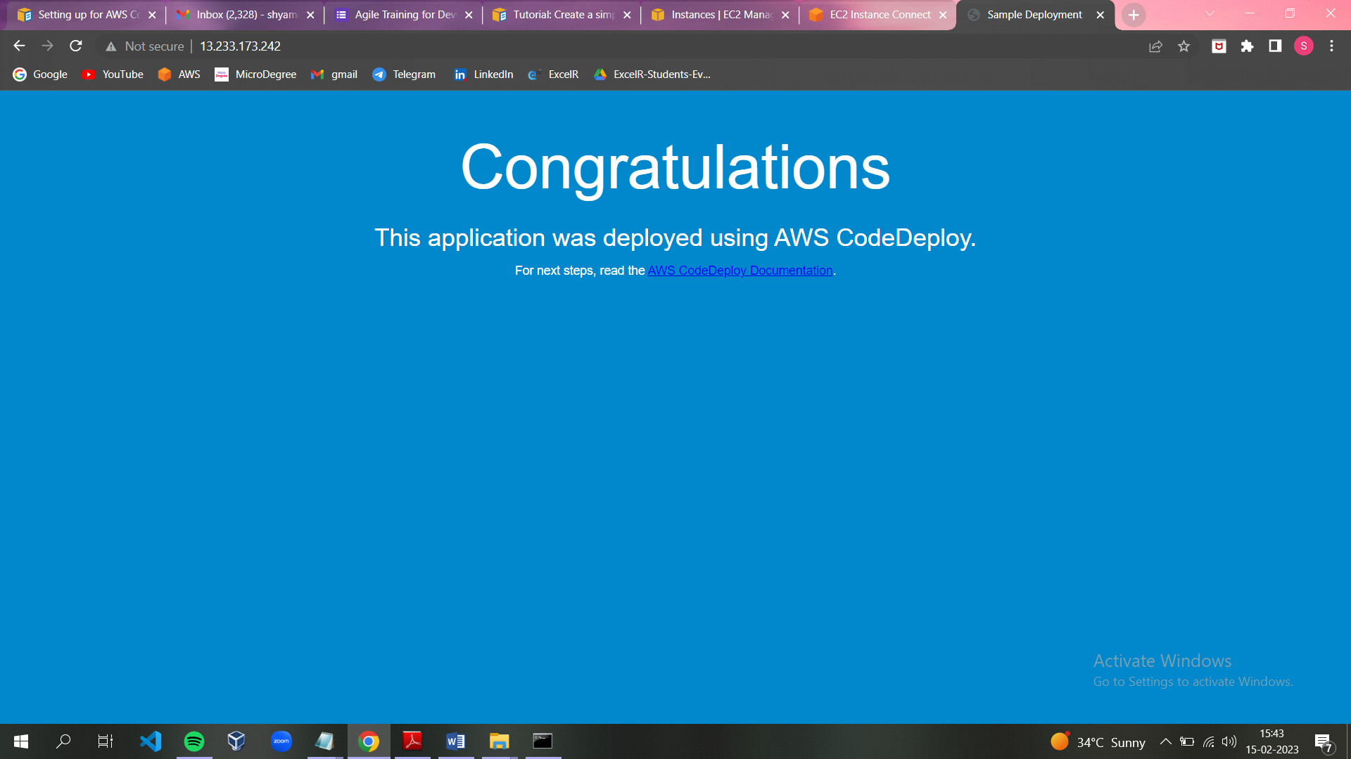

**Modify code in your Code Commit repository to verify your pipeline run successfully:**

* Make the changes in index file.

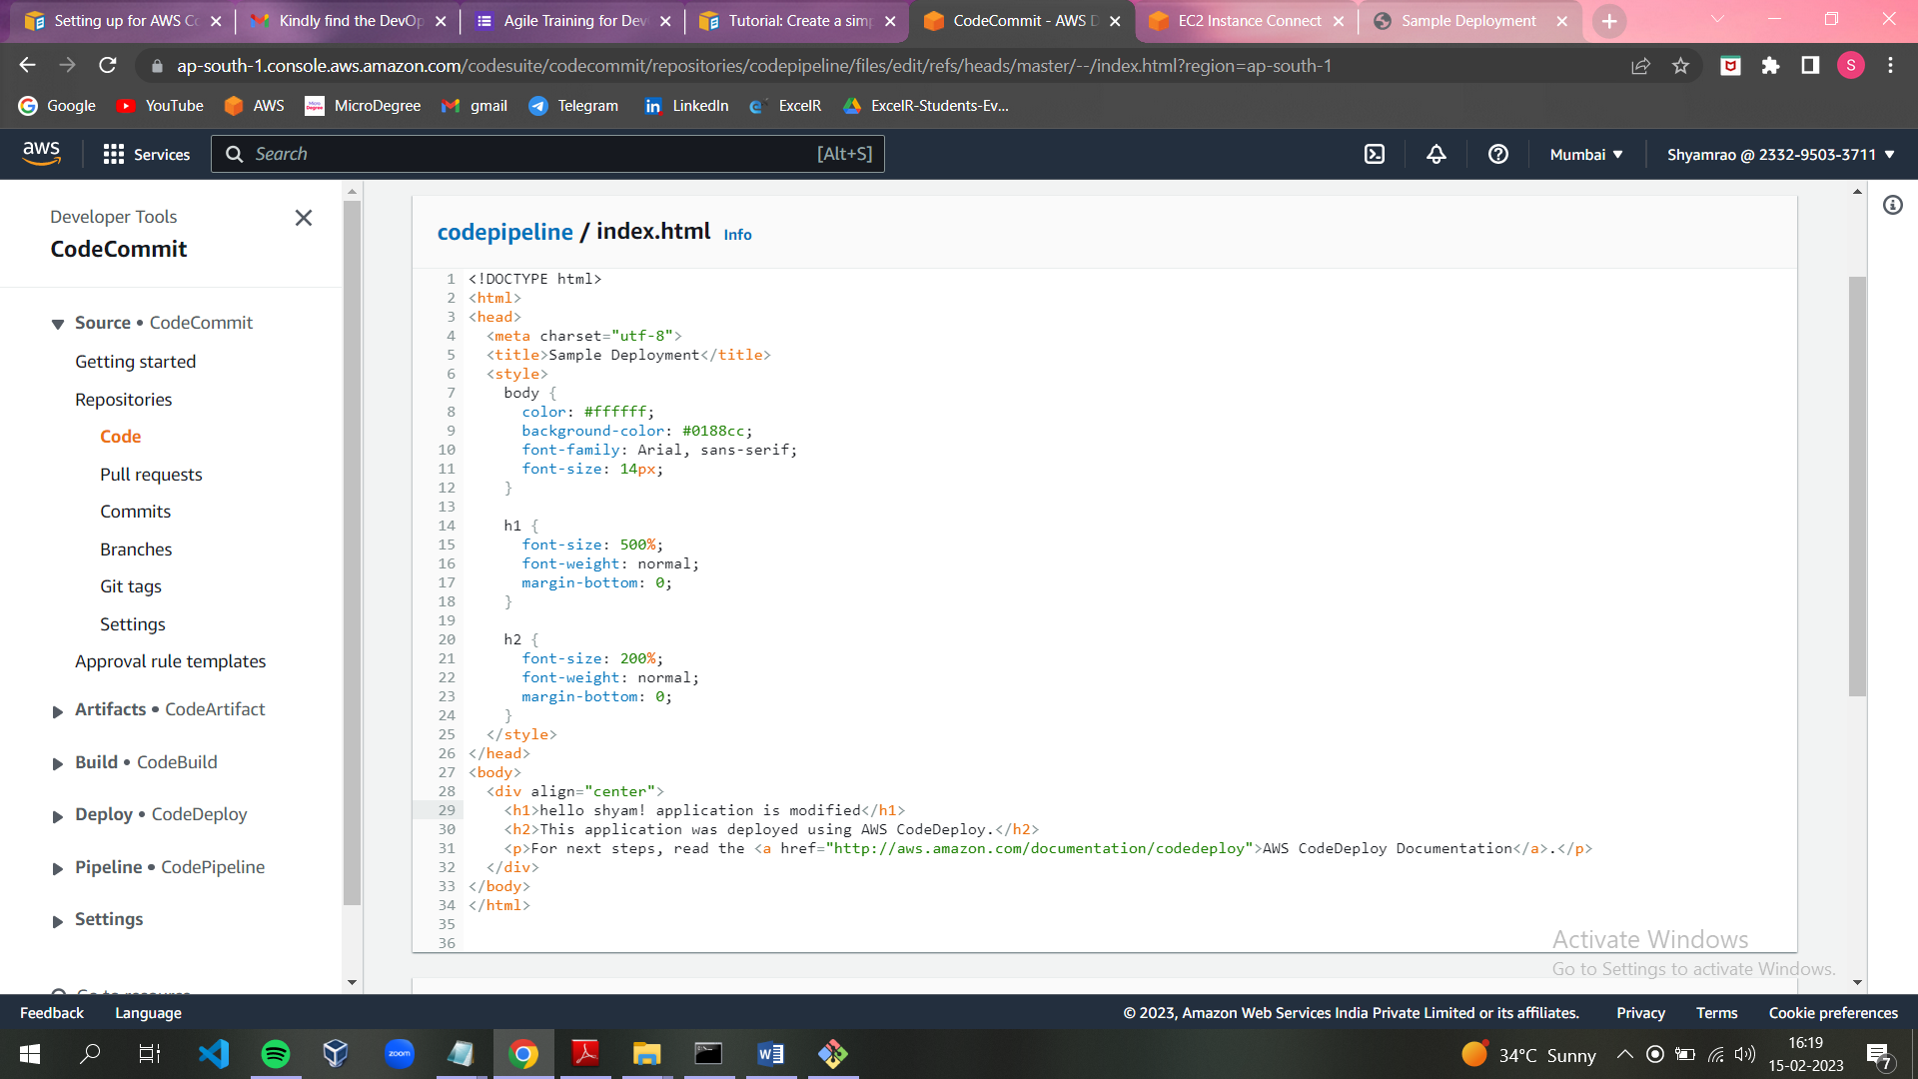

* Edited pipeline will be deploy.

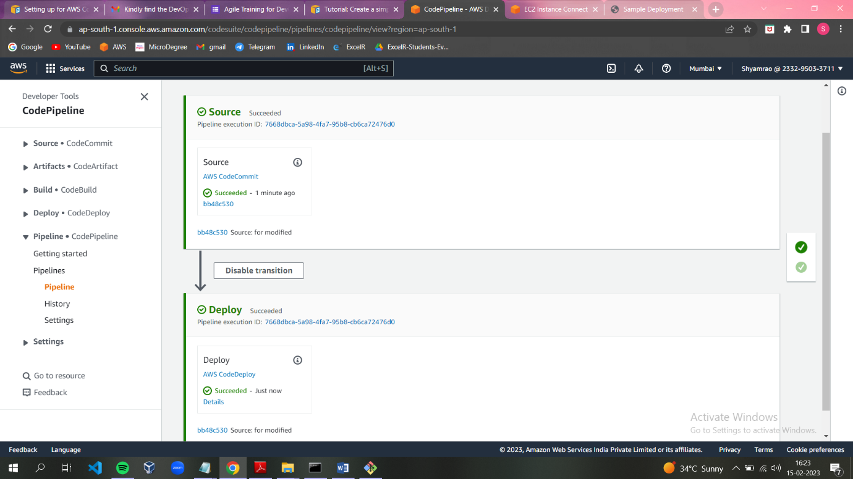

* Copy the ip address of ec2 instance and see the modification:



